Sustainability Auctions: Paving the Way for a Clean and Reliable Energy
Leontina Pinto ¹, Jacques Szczupak¹
1 Engenho Pesquisa, Desenvolvimento e Consultoria Ltda.
leontina@engenho.com, jsz@engenho.com

ABSTRACT
This paper presents a framework for a new, improved auction in the electric energy market: the sustainability energy. The solution is efficient – as it drives market to efficiency, transparent – as conditions, prices and competition information is widely shared by all players, and consistent with all existing market rules, regulations and concepts. A realistic case study with the Brazilian system illustrates the potentiality of the proposed approach and paves the way to an efficient and fair regulatory framework.
Key words: Sustainable planning, Optimal portolio, Renewables, Sustainability

1. INTRODUCTION
Despite of the success of the wind energy on the regulated market, free market is still a challenge. Lack of a specific regulation, long-term contracts (which would attract funding) and natural market uncertainties are some of the well –known challenges yet to be overcome.
On the other hand, there is an untapped market, with a willingness to purchase a distinguished product, with a higher quality than simply energy and power usually sold in auctions: the market for sustainable energy (not to be confused with the MDL). A proper auction, designed to meet source characteristics and demand necessities, could open a new way not only to a wider renewable penetration but also to a more conscious and clean consumption.

2. objective
This work proposes framework for a low-risk, straightforward solution for the eolic energy penetration in any market: the sustainability auctions. According to this approach, each plant will earn a “seal” indicating the associated expected emission reduction (normally achieved by thermal generation replacement), calculated by customized planning/ operation models, consistent with the electrical sector concepts and models.
This expected emission reduction – to be certified by the electrical sector authorities – may be used and exhibit by the interested consumers on associated products or achievements.

3. THE SUSTAINABLE PORTFOLIO
3.1. Basic formulation
This paper presents the basic optimal portfolio formulation. Although designed and implemented for Brazil – that is, for a hybrid hydro-eolic-thermal system, the model is general and may be easily extended to accommodate additional specific characteristics.
(1)
where
x_{t} are the investment variables to be built on instant τ – here represented by
- hydroelectric plants maximum storage volumes and turbined energy
- thermal generators capacity
- eolic installed capacity
- line flow limits
y_{s} are the operation variables on scenario s, instant τ, here represented by
- eolic generation W
- hydroelectric generation Q _{s,}
- thermal generation T
- flows F
- eventual deficits D on load supply
c(x) are the costs associated to expansion variables x during instant and E(d(y_{s,})) are the expectations of the costs associated to operation variables y along future operation scenarios s and time intervals τ
A(x)≥ b are the investment constraints (for instance, budget limits or environmental restrictions)
H^{γ}(y_{s,})≥ +φ(x) are the operation constraints for scenario s and instant τ (for instance, system physical balances/ characteristics or physical limits associated to expansion variables x). γ denotes energy (γ=e) and peak (γ=p) constraints.

Grid representation
As this paper aims the expansion of a continental system, spread along tens of thousands square kilometers, transmission is represented by a multi-area model – detailed enough to accommodate inter-region flow constraints without losing the generation focus. As previously discussed, the overall approach is general and extensions to include power flow constraints is straightforward.

Operation senarios (uncertainties)
Most uncertainties of the expansion problem rely on climatology. It is always hard to anticipate resources lack or surplus as a consequence of extreme events. In addition, as discussed, a highly renewable-based system strongly depends on transmission availability – and a significant transmission failure may lead to a significant loss of load.
The optimal portfolio problem will treat uncertainties as a set S of possible future operation scenarios s associated to the combination of possible climatological time series and, if desired, interconnection line failures.

Objective function
The search of sustainability aims to minimize the total system emissions. While recognizing that a more comprehensive model should also account the total emissions associated to resource construction (steel, oil, logistics, etc.), this paper will target the emissions associated to the generation – mostly thermal units. As huge reservoirs are (at least) environmental controversial and are not expected to be constructed within the planning horizon, there are no significant emissions associated to deforestation.

The optimal planning problem will therefore minimize the objective function

(2)
where c_{qi}, c_{wj}, and c_{tk} are the emissions associated to the operation of each hydroelectric plant i, each wind plant j and each thermal plant k. Generally, emissions associated to hydro and wind plants are null, while thermal plants’ emissions depend on their fuel type and are taken from the figures published by the Brazilian Mines and Energy Ministry, consistent with the International Panel on Climate Changes [7].

Market needs: sustainability incentives
From the market point of view, it is important to know the price of sustainability – in terms of both risks and costs – awareness is the first step to conscious, informed decisions. The key for awareness may lies on the some old and simple sensitivity analysis through some basic indicators as
- The benefit/MWh ratio (the incremental saved emissions achieved by an incremental energy availability – in Brazil, known as Physical Guarantee)
- the benefit/cost (the incremental saved emissions achieved through an incremental investment, measured in monetary units)
Both may be easily obtained directly from the solution of problem (1-3) through selected incremental costs (linear programming dual multipliers), as shown below.

Cost/Benefit considerations
Marginal benefits of each resource (in terms of negative incremental emissions) are given by
(4)
where is the dual multiplier associated to resource r limit constraints (storages, plant and flow capacities, etc.) during instant τ.
Total benefit (emission reduction) associated to each resource is given by
(5)
Benefit/cost ratios are thus written as
(6)
where χ_{r,τ} is the incremental cost of resource r in instant τ and may be used as an “efficiency” indicator able to measure a resource in terms of sustainability.

Incentive design
As sustainability may imply in higher risks and costs, it is important to build a way to achieve desired goals. An efficient, conscious market design will thus include appropriate forms of funding and awareness/preparedness for the potential risks. This is not an easy task. Most consumers, which would in principle support emission cuts, may change their mind if forced to turn off air conditioning/heating on an extremely hot/cold day. Similarly, communities against new coal facilities may doubt their beliefs if forced to face constant outages.
Of course, each market will deal with funding/risks according to their unique needs, perceptions and characteristics. This paper proposes some general schemes, to be adapted to each unique market characteristics.
- A sustainability auction
It is not difficult to find special consumers that would be willing to pay a little more for a sustainable source (as photovoltaic or eolic energy). A sustainability auction would address conscious clients, specific industries and even companies who seek identification with an ever-growing environmental concerned public, who would acquire not “basic” energy – but a “certified” green energy – of course, at a price.
Given a desired emission reduction goal ΔE, it is possible to rank available resources according to their “merit order” efficiency (using, for instance, the benefit/cost ration (6)). The necessary funds will come from a special sustainability auction to contract the ranked resources such as
(8)
where Ω is the set of resources, ranked by merit-order, necessary to reach the desired reduction ΔE
- Incentives for taking risks or costs for reducing risks
Emission reduction may, in certain cases, be achieved by higher risks - take, for instance, the case where thermal plants (maybe more polluting, but reliable) are replaced by cleaner (but unstable) eolic or hydroelectric energy.
Expressions (3) may be used to estimate the risk increase necessary to achieve a desired emission reduction for energy or peak levels at time interval τ
(9)
It is hence possible to ask for “certified volunteers” willing to take more risks to support sustainability – or, conversely, estimate the emission increase due to risk reduction.
- A combined scheme
Of course, the cost- and risk-approaches are not the only options. The overall methodology may be applied to any desired combination, such as economic incentive for risk-taking, carbon-trading or carbon-taxing approaches, etc.

Case Study
The described model was applied to a realistic case study: planning the Brazilian expansion – that is, finding the optimal portfolio of different sources able to successfully supply the load within admissible risks and emissions. We followed the official system representation [8], which divides the system into similar regions, which share similar resources and risks. Error: Reference source not found depicts main load locations (Southeast), eolic plants (beige circles) and small hydros (blue triangles): wind and water harmonically “cover” the country, as a “teamwork”. Dark zones correspond to sparsely populated areas, where most large plants are located; these regions are usually served by the integrated grid.
The following steps describe the overall study:

Study definition
Define the problem: our aim will be, starting from current configuration (2013, illustrated in Fig.3), synthetize the best expansion plan (source mix) for year 2018- a 5-year horizon planning divided into months. All generation, load and system data were obtained from the official data [8].
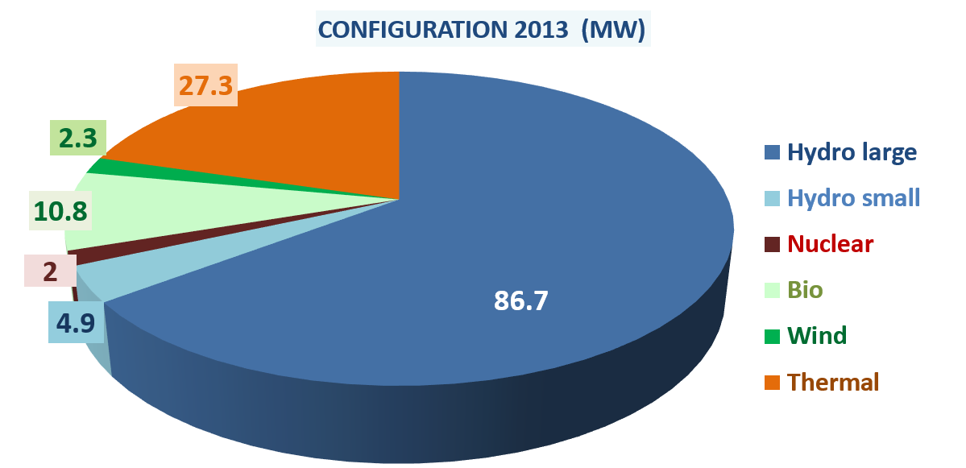
Figure 1 – Brazilian source portfolio – 2013

5.2 Control variables, constraints and objective function
Control variables correspond to new plants (hydro, wind and thermal – photovoltaic are not, at this time, competitive in Brazil). Constraints correspond to load supply and physical constraints for energy and peak levels at each month.
Aiming a better comparison, this study covers two objective functions: economy (minimum expansion cost) and sustainability (minimum emissions).
Figure 2 displays the incremental expansion costs (US$/MWh) for each available source. It is interesting to observe that, due to huge government incentives and tax waivers policies, wind energy costs are actually very low. In fact, large hydroplants and wind energy are the most competitive sources, and there is no real conflict between economy and sustainability – so a cost-effective expansion will follow the green way.
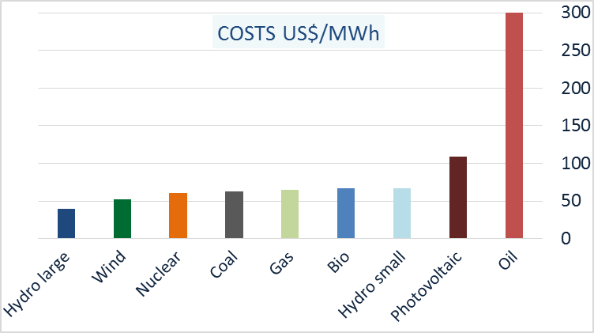
Figure 2 – Average expansion costs by source (as of 2013)

5.3 Uncertainties
Define future generation scenarios for each potential plant (hydroelectric and eolic). Among the possible options available in the literature [9-10] we used a customized model, specially designed for the Brazilian system [11]. If desired, future transmission scenarios consider transmission failure probabilities (in this paper, we will focus only long-distance transmission lines)
- PORTFOLIO RESULTS

The optimal portfolio- transmission risks not enforced
The first approach considers only the climatological uncertainties – transmission failures are not modeled. Following Brazilian regulations, risk constraints (3) were calibrated to a maximum 5% risk level.
As anticipating from expansion costs, optimal economic and sustainable solutions are similar. The expansion plan illustrated in Fig. 3 (new added capacity) is hugely based on large hydroelectrical and wind plants. No thermal plants are built.
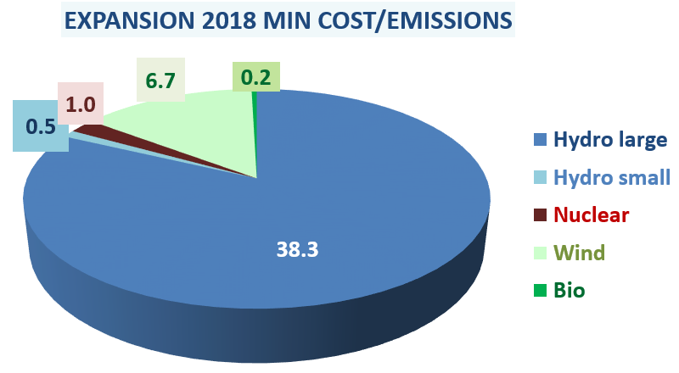
Figure 1 – Optimal expansion (economical/sustainable) – 2018
Although at first sight a “dream solution”, the optimal expansion hides risks. It is widely known that most eolic availability lies on the northeastern and southern regions, far from the main load centers. Transmission failures, normal and even expected, pose a threat to the reliable supply of the main loads. In fact, short-duration failure risks due to transmission lines grow significantly along the time. Table 1 shows the evolution of the loss of load probability (LOLP) and expected energy not supplied (EENS) due to transmission failures – both are far from negligible.
Table 1 – Supply risks due to transmission failures
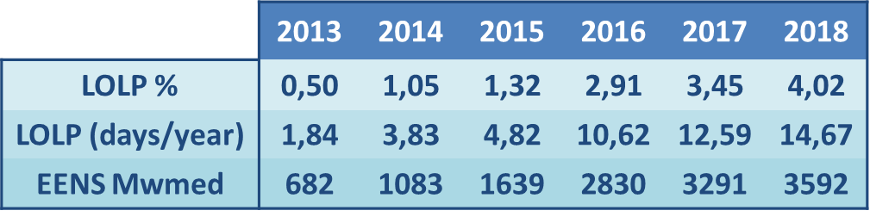

The optimal portfolio- transmission risks enforced
Should the consumer require a more reliable product, it will be necessary to adjust the portfolio to reduce the dependency of the transmission grid. This study will use the sensitivities (9) to evaluate the “emission price” for new risk levels – say, a maximum expected energy not supplied equal to 1.8 GWmed. Table 2 displays the resulting risks/emission figures, while Fig. 4 shows the minimum cost risk-constrained expansion.
Risk reduction was achieved through eolic substitution by small hydro plants located close to the loads and some gas units – the most economic “insurance” against a possible draught and consequent lack of small hydro availabilities. The new expansion is US$ 25 million more expensive than the unconstrained portfolio and adds 8.5 million tCO₂ to the atmosphere.
Table 2 – Emission increase due to risk reduction
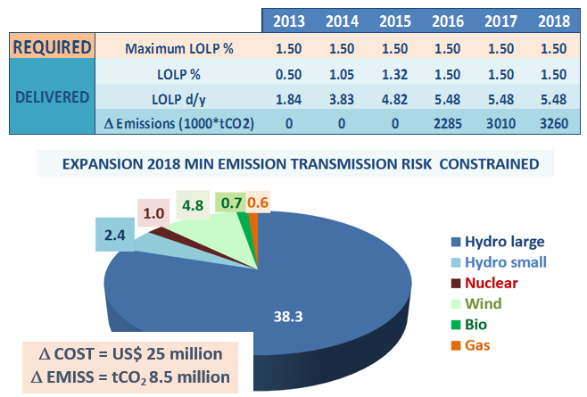
Figure 4 – Risk-constrained minimum emission expansion – 2018

The optimal portfolio- min cost/risk constrained
The best sustainable risk-constrained solution is not the most economic – for instance, coal units would offer a cheaper solution than small hydros, bio-energy or even gas. Actually, Figure 5 shows the minimum cost transmission risk-constrained solution: 28% less expensive, 86% dirtier.
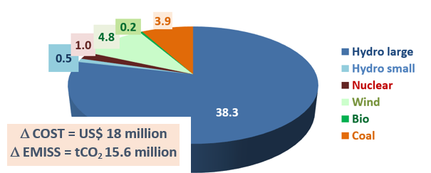
Figure 5 – Risk-constrained expansion – 2018

- THE SUSTAINABILITY AUCTION
Should the sustainability choice prevail, the regulator may promote a specific auction and raise funds for the green substitution. Figure 7 shows the results of a sustainability auction leading to the substitution of the 3.9 GW coal plants by wind, small hydros and gas units, reaching the same minimum emission portfolio obtained in Figure 3.
The average increase on energy prices is almost negligible: around US$ 6.2/MWh – a small price for a significant premium.

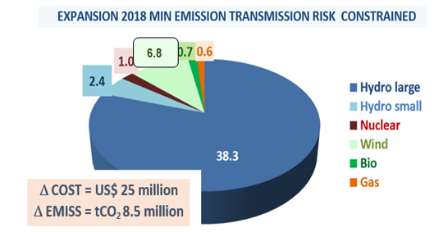
Figure 6 – Sustainable risk-constrained expansion – 2018
- CONCLUSIONS
This paper targets a comprehensive platform for a conscious sustainability option, synthesizing the best expansion plans according to planners’ needs and expectations, as well as associated costs and/or risks. A comprehensive regulatory framework for the sustainability auctions completes the proposed model, offering a market solution for the green energy fund raising or risk requirements to a more flexible, clean solution.
We hope that the proposed approach may contribute to a better, sensible planning, towards a realistic and sustainable energy matrix.
referENCES
- R.Hemmati, R.A.Hooshmand, A.Khodabakhshian, “Comprehensive review of generation and trans-mission expansion planning, IET Generation, Transmission & Distribution, Volume 7, Issue 9, 2013
- L Pinto, P. Leite, “Smart-grid, green energy and responsive consumers: a "smart-green" framework”, IEEE Powertech 2011, Trondheim, Norway
- Bent, R. ; Toole, G.L., “Grid expansion planning for carbon emissions reduction”, IEEE Power and Energy Society General Meeting, 2012, San Diego
- Y. Gu, J. McCalley, M. Ni, “Coordinating large-scale wind integration and transmission planning”, IEEE Power and Energy Society General Meeting (PES), 2013 Vancouver
- B. Zeng, J. Zhang, X. Yang, J. Wang, J. Dong, Y. Zhang, “Integrated Planning for Transition to Low-Carbon Distribution System With Renewable Energy Generation and Demand Response”, IEEE Transactions on Power Systems, Vol. PP, Issue 99, 2013 pp 1-13
- L. Pinto, L.F.Nogueira, “The oprimal expansion planning: the bennefits of a renewable option”, IEEE International Conference on Environment and Electrical Engineering, Wroclau, Poland, 2013
- 2006 IPCC Guidelines for National Greenhouse Gas Inventories. Intergovernmental Panel on Climate Change, Geneva, Switzerland.
- Energy Planning Authority, Brazilian Indicative Expansion Plan, currently available at http://www.epe.gov.br/PDEE/20120924_1.pdf (in portuguese)
- D. Lee, R. Baldick, “Future Wind Power Scenario Synthesis Through Power Spectral Density Analysis”, IEEE Transactions on Smart Grid, Volume 5, Issue 1
- X.Y Ma, Y.Z.Sun, H.L.Fang, “Scenario Generation of Wind Power Based on Statistical Uncertainty and Variability”, IEEE Transactions on Sustainable Energy, Volume 4, Issue 4
- J. Szczupak, S. Crombez, “Long term climatological scenario generation and uncertainty evaluation”, IEEE International Conference on Environment and Electrical Engineering, Krakow, Poland, 2014

