Risk of Wind Farm Operation – The Experience of Running Wind Farms
Sebastian Herzog
Head of Technical Due Diligence Department/ DEWI GmbH
Kasinoplatz 3, Oldenburg, Germany
s.herzog@dewi.de
Keywords: Operation of wind farms, risk management

INTRODUçÃO
Operation of wind farms is a business with clear risk exposure. Meteorological risk, engineering risk and technological risks are the main specific risks of an operational wind farm. Based on several years of experience with operation of wind farms, the purpose of this article is to highlight these major risks and its effects to the wind farm operations.
The stakeholders
Differently from the development phase, operating wind farms are often hold by stakeholders outside the energy business. Finance investors such as pension funds, investment funds, insurances, banks, etc. play a major rule on the investment in wind farms. Such investors usually have no specific background of wind farm operation or energy business in general. Their motivation is usually to invest in a relatively well predictable and relatively stable cash flow that wind farm projects can provide. Looking to the increasing investment figures of 3 digit million dollars each year, the wind business clearly needs such players that can deal with investments of such dimension.
Risk classification
When assessing wind farms in operation and looking particularly to somehow problematic wind farms from an investor’s perspective, this article addresses the typical risks wind farm operators are facing during the lifetime of the wind farms. From investor’s perspective, risks of wind farm operations can be generally classified in two categories:
- Revenue Shortfall and
- Unexpectedly high operational cost.
The diagram below shows the main issues in the operation of wind farms leading to these two major risks.
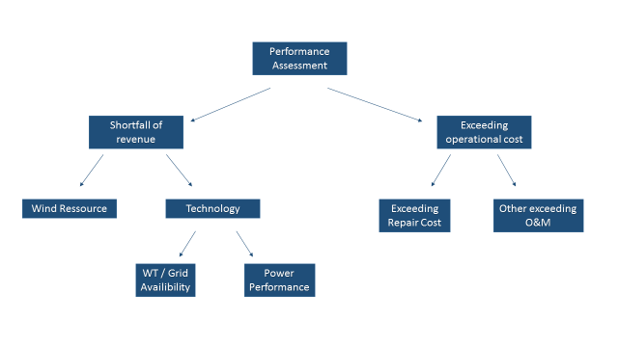
Figure 1 - Wind Farm performance and its main risks
The outcome of the combination of these issues or sometimes even the single occurrence of one of such operational problems leads to poor performance of the wind farm investment. From investor’s perspective this poor performance leads to reduction of available cash flow which again is the basis for the payment of the dividend for the investment.
In the following anonymized cases of poor performance experienced in the past, as well as strategies how to mitigate bad performance in wind farm business.
- Shortfall of revenue
Looking to the number of wind farms that have been assessed in the past, shortfall of revenue is the major performance problem when talking about the risks of wind farms. Shortfall of revenue is the major problem when looking to numbers of wind farms – it is a mass phenomenon that we see in innumerous cases all over the world. On individual wind farm basis shortfall of revenue leads to dramatic reductions of cash flow – over the whole lifetime of the wind farm.
Shortfall of revenue of wind farms caused by a reduced electricity generation is linked to two main reasons:
- Meteorological or
- Technical issues.
Both reasons might lead to a massive distortion of the investment case. These will be discussed in the following sections.
  - Meteorologically induced shortfall of revenue
There are basically two scenarios where the shortfall of revenues is linked to meteorological reasons:
- The wind farm has been financed under a too optimistic wind resource assessment – Higher assumption of wind speeds in comparison to the reality;
- Underestimation of the relevance of further wind characteristics such as turbulence, wind shear, etc.
Both scenarios will be further discussed below.
- Too optimistic resource assessments
Wind energy needs wind. All investment assumptions will be massively influenced if wind speed has been wrongly prospected.
Most – and the most dramatic – cases of poor performance originates from wrong assumptions in the energy yield assessments. Some of these assumptions might be linked to inconclusive wind measurements which end up on overestimated wind speeds. Diverse interests of all involved stakeholders are driving the engineering process to be likely to have an overestimation of later electricity generation. Throughout the past, DEWI has seen multiple examples of wind farms which never met the estimated wind speed - and that during years.
The fact that wrong (namely too optimistic) energy yield predictions are leading to substantial shortfall of revenue itself is astonishing as state of the art software is easily available, being used by developers, independent consultants etc. Hundreds of studies are performed every week throughout the world. It turns out especially astonishing when knowing that the cost of energy yield assessments are typically represented with below 0,1% of the whole investment sum.
Case 1: Wind farms are financed with a relevant amount of debt in order to optimize project economics. Now, taking a European example with typical financing gearing the effect to investors of relatively small variations to revenue is dramatic, when looking to the expected cash flow, that the project should generate.
From several analyses on the impact of a shortfall of revenues in the economics of wind farm projects, the following can typically be concluded:
- 10% of revenue shortfall due to lack of winds leads to 30 - 40% of Cash Flow shortfall;
- 15% of revenue shortfall leads to:
  - 50-60% of Cash Flow shortfall;
  - Several years of no payment of dividends and threat of EoD (Event of Default);
As a general rule the effect of shortfall of revenue translates into the 3-fold its effect when looking to generated cash flow. The table below with a simplified example summarizes the effect.
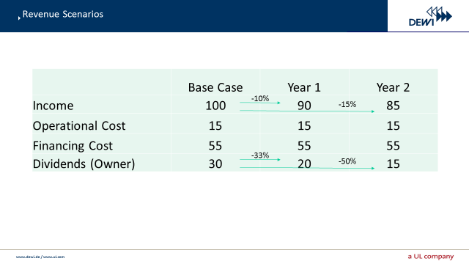
Figure 2: Sensitivity analysis of revenue shortfalls
Looking strictly from an investor’s perspective – the expected cash flow is referenced with 100% shows the effect of 10 and 15% revenue shortfall. It translates into massive reduction of cash flow – even into negative cash flow in one year in this example (year 6).

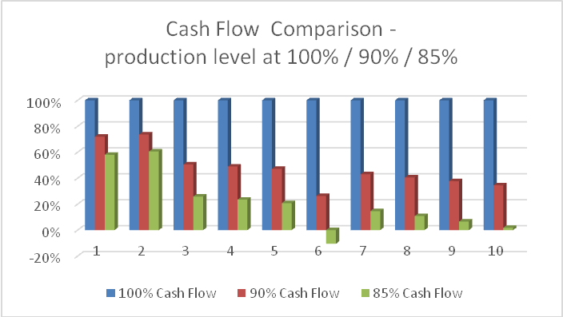
Graph 1: Cash Flow scenarios in underperformance
- Site Conditions vs. Turbine Type
Along DEWIs experience, several wind farms are operating with unsuitable or at least non-optimized turbine types. Again, this effect can be identified basically all over the world.
According to our experience non-optimized turbine selection, can lead to massively lower production than with comparable optimized selection. Reasons for such sub-optimum equipment are partly linked to poor knowledge about the wind conditions at the given site, but likewise to the fast development of turbine technology and long licensing procedures, that “oblige” the owner of the wind farm to equip a defined wind farm site with technology which is not anymore state of the art – and is not optimizing the energy yield for this site.
Case 2: In our experience we found wind farms producing considerably less than 2.000 full load hours per year – considering the today’s value of project sites and the rare good of grid capacity and licensed wind farm sites, such non-optimized sites are a real waste of such high value goods.
- Other Site Conditions
As seen above, wind speed is the key factor when considering meteorological effects of wind farm risks. Besides the wind speed all further variables that need to be considered when planning wind farms such as turbulence at the site, wind shear, wake effect, vertical components etc. are regularly lacking of care and / or knowledge.
All such variables have diverse effects on the performance of the wind farms – either by influencing the average wind speed – so directly the output of the wind farm or by influencing the availability and / or loads to the turbine, so influencing both, the output of the wind farm, the cost of the operations of the wind farm and the durability of the wind turbine or its components.
As such wind resource conditions have a double impact to the economics of the wind farm – once on the income and on the expenditure side of the Cash Flow. Another case will be shown later in this respect.
Mitigation possibilities
When facing wind farm investment possibilities, we recommend to take care that a high quality engineering process has been conducted throughout the whole planning process. Such process should include a site adequate wind measurement campaign and high quality independent energy yield assessments.
It is highly recommended for investors to request own energy yield assessments, performed on basis of the wind measurement in order to verify the whole wind farm planning and identify possible sources of risks beforehand. Such assessments can prevent investors from unprofitable investments that might stay in the books for more than one decade.
  - Technically induced shortfall of revenue
Wind farm performance is always connected to two variables: availability and performance of the selected wind turbine technology. According to DEWIs experience, these are the main reasons leading to poor performance of wind farms:
- Low technical availability of the wind turbines;
- Non fulfillment of the contractual power curve;
Both issues will be addressed in the following.
- Low availability
Probably the most relevant indicator of performance after the average wind speed of an operating wind farm is the availability that the wind turbines reach during the year of operation. A high availability is the key condition to achieve operational success. When operating wind farms today availability rates of 98% should be the target. Lower availabilities rates over longer periods are normally a clear indicator of low reliability of the wind turbine technology, problems that happened during the erection and commissioning process – and continue to influence the wind farm performance, unsuitable wind turbine type to the site conditions or poor performance of the O&M team.
The following factors determine high availabilities:
- A reliable wind turbine technology - suitability for the wind farm site;
- A sound O&M concept:
In order to ensure high availability rates reliable turbine technology that fits to the site conditions and a sound O&M concept need to be secured. When assessing O&M concepts, it is the management of various factors such as 24/7 surveillance, reaction time, trained and experienced O&M personnel, spare parts and components logistics and concepts for preventive maintenance that can prevent wind turbines from longer downtimes. This would include the setup, installation and commissioning of the wind turbine. We inspected various cases where mistakes in the installation / commissioning of the wind farm have led to significant availability shortfall, underperformance and exceeding loads to the turbines.
In our experience and as of today, logistics – fast access to components – and concepts for preventive maintenance are the key to ensure high availabilities.
Case 3: Very recently we assessed a wind farm with several months downtime of one turbine as due to a breakdown of a major component and continues high winds that made the site inaccessible for cranes required for the repair. The operator communicated a loss of revenue of over 50.000 USD with this single event. Obviously preventive maintenance is costly and it cannot prevent from all cases and it is speculation if in this case it could have been identified beforehand. On the other hand – preventing the investor of such long downtimes shows the relation between cost to spend for preventive maintenance and possible negative effect of longer downtime.
Energetic availability
It is a fact that wind turbines usually turn unavailable in periods of higher winds. Therefore, when assessing the energetic availability this is generally significantly higher than the temporal availability. So considering a temporal availability of 96% might easily be reflected in 6-7% of loss of electrical generation. As seen above – 6-7% of loss of revenue might reflect in a reduction of 20% of cash flow.
Mitigation strategies
Low availability can be addressed with careful selection of the implemented technology. However, due to fast development in the turbine development, it is to some degree not possible to assess the outcome of new turbine types or developments.
Once having the technology selected, supervision of the implementation of the wind farm and careful O&M management including predictive maintenance to the main components will further reduce downtime and enable the owner to have a good wind farm performance.
- Power performance
The market value of a wind turbine is very much reflected in the individual power curve, as it is the predominant economical determination of a wind turbine. Besides the importance of the power performance of the wind turbine to the economic success of the wind farm operation, a relatively high number of operators still simply believe in its fulfillment and do not perform power curve verifications once the turbines have been installed.
Power curve verifications will give evidence on whether the contractual power curve is achieved by the installed wind turbine or if the wind turbine is lacking in its fulfillment. It can be seen from two perspectives: a formal perspective of achieving the power curve according to the contractually agreed conditions.
Furthermore, the objective of a power curve verification is to identify even smaller deviations from the contractual power curve enabling the investor to negotiate reassessments of the installation or other mitigations with the turbine manufacturer independently of any contractual obligation.
Case 4: After installing 2 wind farms with the same turbine manufacturer, an operator realized that one of them was underperforming. The approach of the owner to address this situation was to perform power curve verifications for both wind farms. The results are shown below. Here a significant deviation from the contractual power curve can be identified in the bins until reaching rated power.
Although the verification confirmed that both wind farms were operating within the agreed contractual parameter, the results of the PC verification supported the owner in negotiating the improvement of performance with the manufacturer.
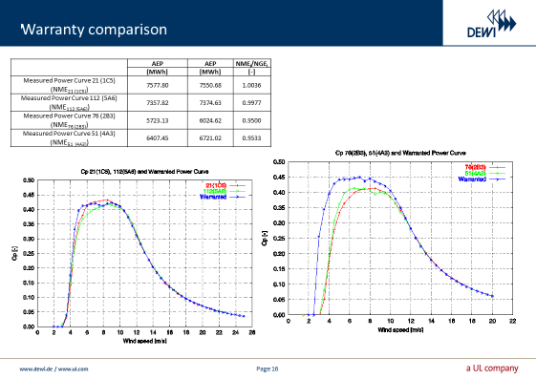
Figure 3: Power Curve Verification
Power performance of wind turbines can be reduced due to various events. One of the key events in the lifetime of a wind farm is obviously the installation and commissioning process. Having passed over mistakes in the installation / commissioning process, turbines might operate with reduced performance, lower availability and usually higher loads – so having a direct effect on the lifetime of the wind turbine or component. But also further events like changes in the operational software or changes in operational parameters can influence heavily the power performance of wind turbines.
Case 5: Another case we have assessed was linked to mistakes in the installation of the wind farm. Having corrected several installations problems, the power curve – here only measured with the wind turbine SCADA, could be changed as follows:
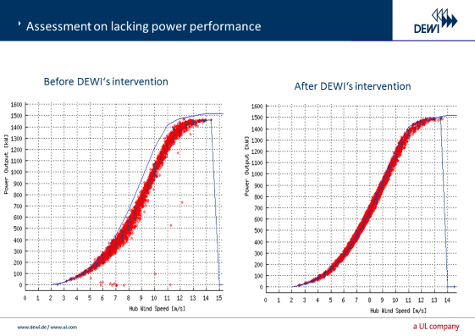
Figure 4: Assessment on Lacking Performance - Example
- Increased cost of operation
As discussed above, revenue shortfall is clearly the most relevant risk to the performance of a wind farm investment. However significant increase of operating cost might heavily affect the cash flow of operating projects. In single cases such increased cost of operation turns out as dramatic as the shortfall of revenue. Namely when looking to markets with low remuneration rates the economics of wind farm projects are very tight. For this reason, an optimized management of operational cost is essential to succeed in the operation.
As per DEWI’s experience, the most tangible part determining the success of a wind farm in terms of operational costs are the O&M and repair cost. Generally wind farm owners experience high O&M and repair costs from two sides:
- Cost forecast and repair reserves are not adequate and sub-estimated at the moment of acquisition / start of operation of the wind farm;
- Even relying on a realistic O&M / repair forecast, the selected technology requires repair cost that are higher than the benchmark would be.
The first reason can be addressed through reasonable care during the investment phase. The second problem is rather hard to assess beforehand and usually hits the operator with two effects:
- low availability of the wind farm – thus lower electricity generation and
- Unforeseen increase of cost which can lead in extreme cases to claims between the manufacturer and the operator.
Case 6: One of our customers operated a wind farm with problems in the blade structure, provoking the wind turbine to shut down due to vibrations when operating under heavier winds. To solve this issue and bring the turbine back to operation, continued local maintenance teams were required in the wind farm – ending up in maintenance cost far outside the usual level.
Being able to show that such disturbance was induced from poor turbine or here blade quality, the owner in this case was able to oblige the manufacturer to take care of the additional maintenance requirements.
Exceeding operational cost is usually not the single problem in wind farms. Quite frequently those exceeding costs are linked to low availability rates as the following cases might show:
Case 7: Further experiences have been made in complex terrain, having wind farms operating in mountainous regions. High components of vertical winds are causing damages to main bearings in one case and even breaking blades due to vertical components of winds.
Mitigation strategies
Again, as seen above, high quality engineering from the very beginning of the wind farm planning until take over and active management of the operations would be the tools the owner of a wind farm should take care of in order to reduce risk in operation of wind farms.
Serial component damages
An extreme case of increased operational cost is serial damages to components of the wind turbine. Some cases are quite known within the wind energy community and do not need to be reflected here. It shows that even high quality providers of wind turbines are facing such cases of serial damage to components.
When facing discussions between the various involved parties – usually the owner and the manufacturer – root cause analysis to identify the reason of component breakage is crucial to defend the owner interest based on documentary assessments, inspections and usually assessment of the environmental conditions. Performing such kind of 3rd party witnessing enables the owner to argue objectively with the manufacturer about damages and respective liability. For such kind of assessments, specialized teams are set up for the questionable component.
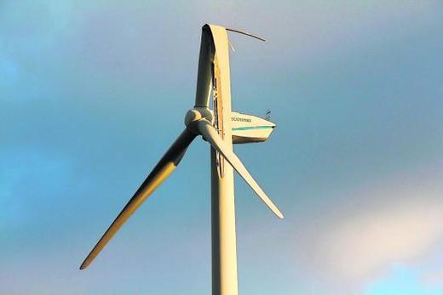
Figure 4: Severe Component Damage - Example
Conclusion
The following can be concluded from the experience of wind farm operations in order to reduce risk of shortfall of revenue:
- High quality engineering from the very beginning of wind farm planning until installation;
- Reliable technology to be selected for the site;
- Skilled and experienced teams for installation and operation and maintenance;
- Continuous follow up of operation through periodical turbine inspections, verification of operational data, etc.
Finally wind farm operations requires an active management.
Even having all such in place, risks will still exist, but the indicated measures should enable the operators to considerably reduce risk.

