Testing for Certification of Rotor Blades – Today and in the Future

Arno van Wingerde¹ Florian Sayer¹, Eric Putnam ¹
1 Structural Components
Fraunhofer IWES
Am Seedeich 45, 27616, Bremerhaven, Germany

arno.van.wingerde@iwes.fraunhofer.de, florian.sayer@iwes.fraunhofer.de, eric.putnam@iwes.fraunhofer.de

ABSTRACT
This paper describes the current methods for tests for certification of blades of wind turbines – and some of its inherent weaknesses and a possible way out. It is based on the IEC 61400-23 [1] of which the leading author was a committee member, outlining the procedure and its weaknesses and presenting a possible way forward based on [2], which is being investigated together with DNV-GL.
Keywords: Certification, Rotor Blade Testing.

INTRODUCTION
The current certification process for rotor blades of wind turbines is essentially based upon a number of coupon tests to establish the material properties, followed by a full scale blade test to check the design of the blade. Hardly anything is tested on the intermediate subcomponent level, except for the root connections, where subcomponent tests are carried out. This situation contrasts starkly to other industries where tests at the intermediate level are far more commonly used to verify the design assumptions and optimize structural details, see Figure 1.

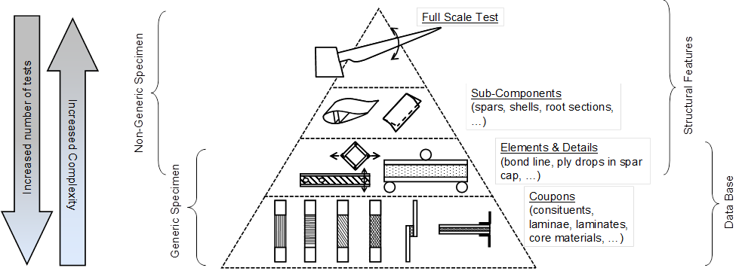
Figure 1 – Testing hierarchy according to IEC 61400-5 [2].
Not only does the current procedure in principle require a full scale blade test when even a single material or structural detail is exchanged, but the available worldwide test capacity, especially for larger blades, is insufficient to carry out all required tests, causing major delays in blade development. Another, potentially even more harmful aspect is that a blade test is hardly a good occasion to test new details, as the failure of such a detail after millions of dollars of development and manufacturing would cause the blade to fail – potentially ending the career of the responsible engineer. Thus, the safe way, the one used by industry, is to “recycle” the design of the last blade and just making small changes.

Full scale blade testing according to 1 IEC 61400-23 [1]
The work on 61400-23 was first published as a technical specification in 2001. Work has continued since then, resulting in a standard which has been published in 2014. It is worth noting that the IEC standard requires a dynamic test of the blade. From a technical point of view this makes perfect sense: many manufacturing errors cause failure during fatigue tests – after the static tests have been successfully concluded.
A full-scale blade test is current method of proving experimentally that a design meets the required standard. In the IEC61400-23 the purpose of a blade test is outlined as follows:
“The fundamental purpose of a wind turbine blade test is to demonstrate to a reasonable level of certainty that a blade type, when manufactured according to a certain set of specifications, has the prescribed reliability with reference to specific limit states, or, more precisely, to verify that the specified limit states are not reached and the blades therefore possess the load carrying capability and service life provided for in the design.
Additionally, tests determining blade properties have to be performed in order to validate some vital design assumptions used as inputs for the design load calculations. It has to be pointed out that the required blade property tests do not cover all design assumptions.
Normally, the full-scale tests dealt with in this standard are tests on a limited number of samples; only one or two blades of a given design are tested, so no statistical distribution of production blade load carrying capability can be obtained. Although the tests do give information valid for the blade type, they cannot replace either a rigorous design process or the quality system for series blade production. Furthermore, the tests described in this standard are not intended to be used for the testing of mechanism function nor to establish basic material strength or fatigue design data for blades and/or components.”
It is important to mention what is inherently not tested:
• Validity of design loads
• Environmental conditions
• Scatter in results
• Changes in production or design
Also, the use of 4 directions for loading, does not test the full circumference of the blade, the omission of torsion avoids failures seen in the field, such as leading edge failure, the conversion from spectrum to constant amplitude loading using Miner’s rule is only correct for one material.

Overview of the IEC 61400-23 Blade Test

Measuring Blade Properties, Installation of Sensors
To verify that the design and manufacture together produce a blade with the specified design weight and manufacture upon arriving at the testing facility the blade is weighed and its center of gravity is determined. The blade may or may not be weighed with the root bolts installed. The installation of sensors, mostly strain gauges, occurs right after weighing the blade so that the gauges can be utilized throughout the testing program. The measurement of the natural frequencies of the blade provides the first chance for the designer and manufacturer to experimentally verify the stiffness and mass distribution. A comparison with the calculated natural frequencies can quickly reveal flaws in design assumptions or deviations from the design during the manufacturing stages.

Static Blade Tests
The static blade tests apply the most critical loads along the length of the blade to verify (1) that these loads can be resisted and (2) that the strains and deflections match the predicted values from the calculations. Setup of a static test consists of cantilevering the blade from a large and rigid support block and fixing loading frames to the blade, as shown in Figure 2 (left). IWES uses the load frames and pulling concept, downward vertical that is shown in Figure 2 (left); however, other concepts are also widely used and allowed by the standard.
As previously stated, static tests are often conducted for 4 directions, where each angle is a 90º rotation from the other, and the goal is to load the main structural elements in the flap and lead-lag directions. For the flap tests this means the load carrying spars on the high and low pressure sides. For the lead-lag tests this means the trailing and leading edges.
The four directions and the axes of the blade to which the loading corresponds are:
- flap_{min} = high pressure side under compression
- flap_{max} = low pressure side under compression
- lead-lag_{min} = trailing edge under compression
- lead-lag_{max} = leading edge under compression
Loading for a static test is conducted quasi-statically with the load applied in a few load steps up to the 100% required test load. At each of these load steps the experimental deflections and strains can be verified against the expected and a determination can be made on whether to advance the test further. At 100% the load is held for a minimum of 10 sec to allow for the load to settle before the load is released back to zero.

Fatigue Blade Tests
To verify the designed lifetime, dynamic fatigue testing is conducted on the blade. As with the static testing, the loading is directed to load the structural elements in the flap and lead-lag directions. IWES employs the use of an externally mounted hydraulic cylinder as an exciter with either the cylinder pushrod or a pushrod coupled to the movement of the cylinder attached to the load frame. Figure 2 (right) illustrates the setup of a fatigue test for a bi-axial fatigue test; therefore, both the flap and lead-lag direction load structures are shown. The industry standard is not the bi-axial fatigue testing as shown, but is uni-axial testing, in flap or lead-lag direction. Both tests will be conducted; one after the other, but the order of the two is not significant. The loading cycles for the flap and lead-lag tests typically varies between 1 and 5 million cycles, which depends on the load amplitude that is applied to the blade.
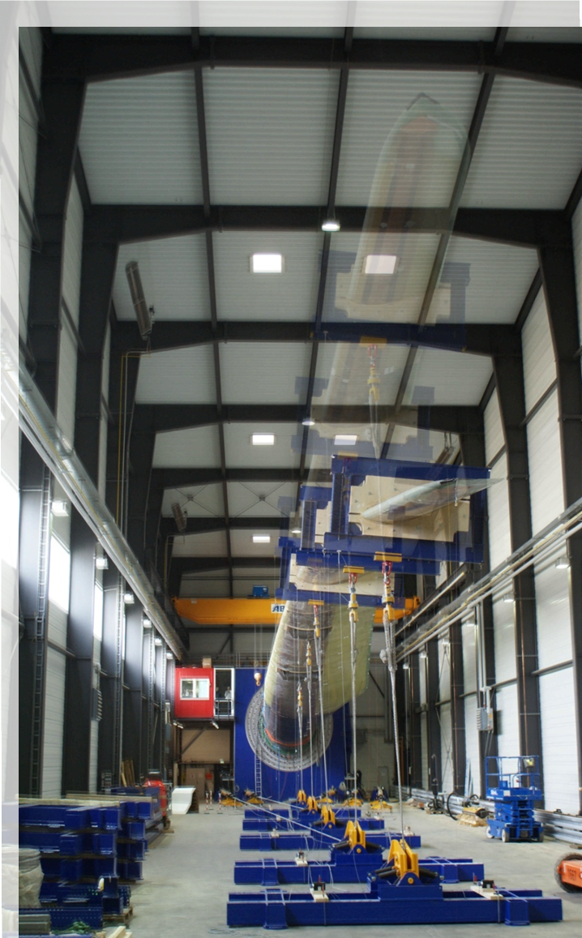
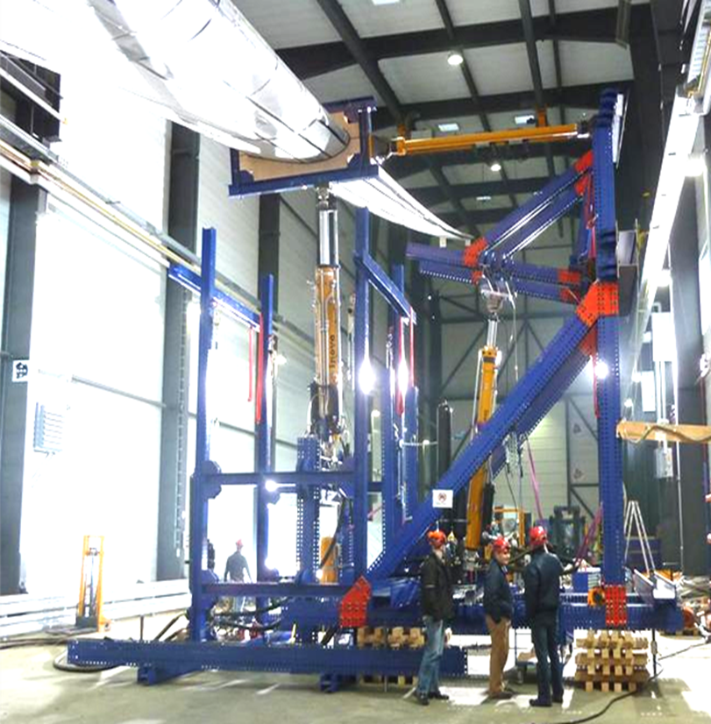
Figure 2 – Static Test and dynamic bi-axial Blade Test.

Post-fatigue Static Tests
At the end of the testing of the rotor blade an additional series of static tests is conducted to verify that the blade can still withstand the most critical load cases even near the end of its useful life-span.

Conclusions on the full-scale blade test
A number of advantages and disadvantages are inherent to the full-scale blade test and will be discussed here as a starting point for the alternatives.

Advantages of the full-scale Blade Test
A full scale blade test is essentially a rather efficient way to test a blade: the support structure can be bolted to the blade root using is the existing blade to turbine connection, which is both convenient and realistic.
Also, with one test series as outlined in Chapter 2, static-dynamic-static, a large part of the blade structure is tested and the test has a fairly direct relation to the loads the blade encounters in practice with relatively simple boundary conditions to observe.

Testing time related Problems with full-scale Blade Test
The requirement for fatigue tests of the rotor blade, while sensible from a technical point of view, increases the testing time for rotor blades. Most blades are tested at their natural frequency, in order to save on energy and reach a proper bending moment distribution over the length of the blade. For large blades, the dead weight of the blades becomes a dominant load case, one that cannot be countered by adding extra material, forcing the designer to maximize the utilization of the blade material. Together with the rather severe load factors on the fatigue load, this causes the fatigue load on the blade to be at the edge of the technical possibilities, causing many designers to increase the number of cycles in order to be able to reduce the fatigue loads. This effect often results in blade tests with for instance 5 million cycles, which would require 5 months full-time testing for just the flap direction, or as much as one year for a complete blade test.

The road forward: KompZERT
The project KompZert (COMPonent CERTification – in German) which is being carried out between DNV-GL and Fraunhofer IWES aims to lay the foundation for a subcomponent-based methodology for blade development and certification.
Aim of the project is the augmentation of the current standards in wind turbine testing, the IEC 61400-x series, by a separate standard for subcomponent testing, such as the beam test for bonding paste [3]. Two points are deemed essential to establish this standard, namely the definition of a catalogue of rotor blade details test options, followed by implementation of these options into standards, since it is vital that the test results are accepted by the certification parties. Having this rather modest project, €400,000 over 3 years with just two parties, namely DNV-GL and Fraunhofer IWES, assures a small, focused project that may serve as kick-starter for more elaborate projects, within the IEA, IEC or for instance the EU, which in turn could provide the basis for a future IEC standard.
A major problem, as outlined by the various blade manufacturers is that the load factors on material and subcomponent tests tend to be higher than for full-scale rotor blade tests, which all but prohibits manufacturers from using subcomponent tests to augment their current material and full scale blade tests. A possible way out here would be the use of options to lower load factors.
The current draft of the IEC 61400-5 [2] states: “Where a dedicated test program has not been conducted, the partial safety factor is to be calculated by an empirical approach using the partial safety factors listed below”.

Principles of subcomponent testing
In order to be effective, a subcomponent test would have to fulfil a number of criteria:
- Cover the most critical details and load cases in the blade or blade detail, or in case of a modification to an existing blade, the modification.
- Adhere as much as possible to a certain “standard” so that manufacturers, certification bodies and test institutes alike know what to do and what to expect and gain comparison material and experience in the test alike, without having to reinvent the wheel with every new test.
- Manufacture the relevant parts in a representative way, so that residual stresses, stress concentrations and defects may occur in a similar manner as in the blade strucure4. Prove that the subcomponent test carried out is relevant for the load case studied.
Note that the subcomponent test is essentially used to verify and augment the numerical models, so a complete 1:1 incorporation of the complete boundary conditions that occur in a blade subcomponent often is not required. However, the test results combined with the numerical results should be usable to gain confidence that the loads in the blades and their effects can be adequately covered. In practice this is a very difficult requirement and it is to be expected that a significant effort will be needed to establish a solid basis for future standards.

CONCLUSIONS
Due to the high cost pressure in the industry, the need for a high reliability and the relative short time to market for new developments, the certification process is a crucial step in the development of new products. Due to the monolithic nature of the blades, but also due to the lack of standards and obstacles in the certification process, the use of subcomponent tests within the rotor blade has been limited to date and mostly open to larger parties with a lot of experience. Opening the option of testing subcomponents in lieu of a full scale blades and acknowledgement of the results by the certification bodies with adequate partial factors will be a tremendous boost for the whole industry and help achieve to same tremendous growth that has marked the industry to date, coupled with an increase in quality and reliability necessary for tomorrow’s blades.
Acknowledgements
The support by the Federal Ministry of Education and Research of Germany for this project is gratefully acknowledged..
REFERENCES
- IEC 61400-23. 2014 .WIND TURBINE GENERATOR SYSTEMS –Part 23: Full-scale structural testing of rotor blades. IEC.
- IEC 61400-5 RevJ 2013. WIND TURBINE GENERATOR SYSTEMS –Part 5: Wind Turbine Blades. IEC (draft version).
- Sayer, F., Antoniou, A.E., van Wingerde, A.M. 2012. Investigation of structural bond lines in wind turbine blades by sub-component tests. International Journal of Adhesion and Adhesives, Vol. 37, 129-135.

BIOGRAPHIES
A.M. van Wingerde
Born in The Hague, The Netherlands 18. February 1961.
M.Eng., Ph.D. Delft University of Technology, The Netherlands 1987, 1992 Civil Engineering, Steel structures.
Postdoc: University of Toronto, 1992-1997.
Member of IEC-61400-23 and 61400-5
Coordinator of a number EU projects, leading the establishment of the rotor balde test centre of Fraunhofer in Bremerhaven from 2008-2012.

