Complementarity of Wind and Solar Energy in Northeastern Brazil
Caarem Studzinski¹, Rita de Cassia Marques Alves¹ and Pedro A. C. Rosas²

¹ Centro Estadual de Pesquisas em Sensoriamento Remoto e Meteorologia - Universidade Federal do Rio Grande do Sul -UFRGS/CEPSRM. Av. Bento Goncalves, 9500- Campus do Vale – 91501-970 - Porto Alegre, RS – Brazil +555133086361.
² Departamento de Engenharia Elétrica e Sistemas de Potência - Universidade Federal de Pernambuco (UFPE) – Rua Acadêmico Hélio Ramos, s/n, Cidade Universitária, Recife, 50740- 530, Brasil.

caarem.studzinski@ufgrs.br, rita.cma@terra.com.br; prosas@ufpe.br
Abstract
Northeastern Brazil has a significant potential in wind and solar radiation, available land and an urgent need to create economic alternatives to mitigate poverty. At the present, more than two thirds of wind farms in the country are installed or being developed in the region. As their electric infrastructure are designed to full rated power, in this study it is explored the complementarity of energy production using solar PV in the same land and infrastructure of the windfarm. Five different regions with eight data points were analyzed in terms of wind and solar radiation regimes. A wind power typical day and year were constructed and a PV performance simulation was done. Using Solar PV together with wind power results in a smoother energy and could add about 20% more energy, using the same transmission system. Wind and solar energy as a single grid hybrid power plant grid connected is the next renewable solution to be explored.

Keywords: hybrid power plant, curtailment, wind energy, solar PV, Northeast,

1. INTRODUCTION
Renewable energy is considered a key factor for a sustainable society [1]. The way to mitigate energy risks under the climate change extremes events, as such as the prolonged drought in Brazil, and at the same time address the poverty problem goes through energy efficiency and the usage of renewables. Studies about climate change impacts on a short and long future availability and reliability of wind power indicate that wind will continue to be an alternative for expanding renewables [2][3][4].
Brazil’s energy matrix relays mostly on renewable sources, with more than 59.8% from hydropower generation and 4.8% from wind power[5] .The hydroelectric power generation is based on water reservoirs, most of them located in the subtropical region, where the precipitation is highly interconnected with ENSO phenomena [6][7][8]. Subject to long periods of dry spells, the water once abundant, is in a dispute among electricity companies, water suppliers, industries and farmers. In addition, whenever there is a shortage in the rainy season, thermoelectric power plants, using large amounts of water to cool off, are dispatched.
Since 2009, Brazil uses wind for electricity generation, achieving more than 7 GW up to 2015 and have a projected wind power scenario of 27GW, by 2023. More than 68% of these wind farms are located in the Northeast region [9] due to the vast, yet not totally explored, wind potential[10] and land availability. Solar photovoltaic (PV) energy is growing fast, with a significant solar potential estimated for the same region[11]. Northeast Brazil’s is under a semi-arid climate with many recurrent dry years. It is hash to have agriculture or cattle as economic activity in a dry soil with such volatile water availability. The use of the land for renewable energy “harvest” would mean a significant, stable, steady earning and an effective tool to mitigate poverty.
In general, a wind farm siting leaves free surfaces to install a photovoltaic power plant free of shading effects [12] if considered the distance required between turbine lines to minimize wake, to allow service roads, substation and environmental constraints. Worth to mention that in the Northeast the majority of wind farms are oriented south-north due the predominant easterly trade winds.
This study focus on the use of wind (W) energy associated with solar photovoltaic (PV) as a complementary system, using the electrical infrastructure previously installed for windfarms. As the Brazilian national grid operator requires windfarms to be projected to convert the full rated power to the system, and in general, the windfarm in the region have a capacity factor range of 40-55%, letting some bandwidth to insert solar. A positive synergy between the two energy plants is expected due operation costs reduction, grid connection, environmental permits and energy reliability.

2. Location and Database
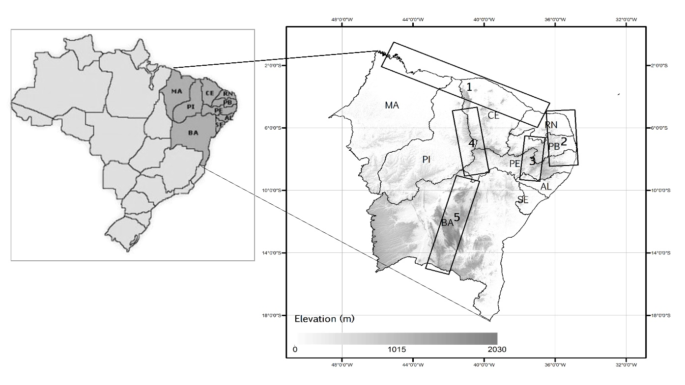
The subject of this work comprehends the region where more than two thirds of brazil’s windfarms are installed[9]. According to their distribution the region was divided into five (5) areas, as shown in Error: Reference source not found. Area 1 comprehends the north nearshore portion of Ceará and Rio Grande do Norte, where the predominant large scale trade winds and sea breeze circulation have different patterns of interaction, according to the coastline shape and orientation. For this area two datasets near the shore (1A and 1B) and one at higher elevations (1C), approximately 60 km distant form the coast were analyzed. The area goes from a dry period from July to February and the short rainy season from March to June which is quite related to the variability of sea surface temperature at Pacific and Atlantic Oceans [13]. Area 2 goes alongside the east shore of the region, under a tropical humid climate with trade winds associated with the sea breeze circulation. Two sits represent the area one by the seashore (2A) and another in the south-westward direction approximately 20 km inland (2B). Area 3 site represents a complex plate called Borborema Belt with a climate transition from tropical humid to semiarid. Area 4 site is located in a continental plateau into the semi-arid caatinga (savannah) where a significant share of new wind and solar farms are being installed. Area 5 site illustrated the windfarms in high-altitude semiarid climate area, known as São Francisco Craton, with a high density of operational wind farms in Brazil.
Figure 1 – North-eastern region with the 5 focal areas of study. Shading represents higher elevations.

Wind Data
It was used anemometric measurement campaigns for each site, with a minimum three-year long period at 100 meters’ height, with wind speed and direction averaged every 10-minute interval. Confidentiality agreements do not allow the identification of the exact locations from where data were extracted. All datasets undergone through a quality analysis process with anomalous or flagged data discarded. Wind had a 99% of recovery rate (speed and direction).
Wind data were grouped in a cumulative frequency distribution with 0.5 m/s intervals and fitted in the Weibull distribution, which is the most widely used statistical tool to analyze the characteristics of wind regime [14–17]. The shape factor k and C were found. The k and C parameters for all sites indicate the effect of the trade winds sustainable easterly wind pattern with narrow departure from the average.
The wind regimes shown in Error: Reference source not found indicate some differences. Area 1 shown in a) has two coastal sites (A and B) with a diurnal cycle; the difference between the hours of maximum and minimum are due the coastline orientation; while site A has a southwest-northeast line where sea-land circulation competes with the trade winds, resulting in blow average wind up to 2p.m., site B has a southeast-north western coast alignment with a diurnal wind pattern once the sea breeze peak and trade winds are aligned. Site C has a typical hills nocturnal pattern. It is interesting to point out that the average for the three sites ends up as a smother and steady cycle with less than 0,8 m/s of interval between the higher and lower winds. Area 2, at easternmost tip of the country has a typical coastal wind regime, with a strong diurnal wind speed (Error: Reference source not found-b)). These two sites have higher shape factor which highlights the association of large scale trade winds and sea breeze circulation, perpendicular to the shore.
The higher elevation inland areas as in site 3, 4 and 5 have local valley-mountain circulation with a mostly nocturnal wind regime. Some differences shown in Error: Reference source not found-c) are due to geographic distinct configurations. The wind annual cycle, shown in d), indicates all eight sites with low wind speed during rainy season (March to June) and the strongest winds from august up to October (dry season).
The wind power density was calculate using the equation of kinetic energy of air masses with a swept are of a 125-rotor turbine and the air density at each site, as shown in Error: Reference source not found with some characteristics of the wind pattern. In terms of power density all sites have a reasonable (250 - 400 W/m²) potential for wind energy.
Table 1 - Wind Characteristics with site elevation, averaged velocity at 100 meters, Weibull parameters (k and C), air density at the site, power density and months of maximum and minimum wind velocity
Area | Site | Elevation (m) | Average Wind at 100 meters (m/s) | k | C  (m/s) | (Kg/m³) | Power Density (W/m²) | Max | Min
1 | 1A | 30 | 8,6 | 4,1 | 9,5 | 1,14 | 362,8 | SEP | MAR
1 | 1B | 10 | 9,1 | 3,9 | 9,8 | 1,15 | 399,2 | OCT | APR
1 | 1C | 800 | 8,0 | 3,4 | 8,9 | 1,07 | 277,6 | OCT | APR
2 | 2A | 20 | 8,1 | 4,3 | 8,9 | 1,16 | 304,4 | OCT | MAR
2 | 2B | 70 | 8,0 | 4,7 | 8,7 | 1,15 | 293,3 | SEP | APR
3 | 3 | 800 | 8,4 | 4,2 | 9,2 | 1,04 | 299,5 | AUG | APR
4 | 4 | 800 | 9,2 | 3,0 | 10,4 | 1,06 | 416,8 | AUG | MAR
5 | 5 | 825 | 8,3 | 3,4 | 9,3 | 1,07 | 308,8 | SEP | MAR

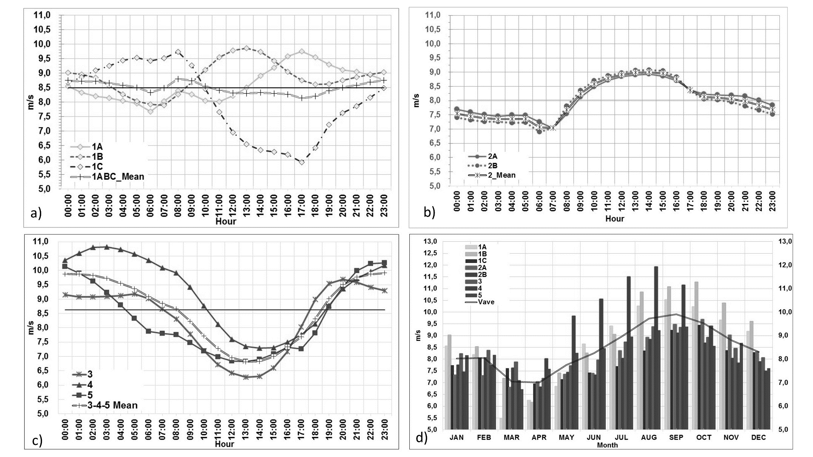
Figure 2 - Wind regimes: a) Typical day for Area 1 (A, B and C sites); b) Typical day for Area 2; c) Areas 3, 4 and 5 hourly averages of a typical day; and d) monthly wind oscillation for all sites.

Solar Radiation
Hourly averages of global horizontal radiation data (GHI), measured by a first class pyranometer, air temperature, relative humidity and pressure with roughly 10 years of measurement were extracted from Brazil’s National Meteorological Institute (INMET) database. A measurement within 50-km radius of each windfarm was selected to the analysis. After a quality assessment analysis 85% data were considered in the study. A compilation of averaged variables for all the sites and its characteristics are shown in Table 2. As some stations were at a different elevation than the wind farms, temperature, humidity and pressure were corrected using the adiabatic lapse rate and hypsometric equation. Fig. 1 shows the daily and annual pattern of solar radiation. As Northeast has a rainy season driven by intertropical convergence zone (ITCZ) displacement [18,19], the minimum radiation period occurs at the rainiest month and the maximum during dry season as illustrated
Table 2 - Global horizontal radiation (GHI), mean temperature, relative humidity (RH), and month of higher and lower radiation for each site.
Area | Site | Latitude (°) | Longitude (°) | Elevation (m) | GHI (W/m²) | Mean Temp (°C) | Relative Humidity¹ (%) | Max | Min
1 | 1A | 5,2 S | 36,5W | 7 | 5,8 | 25,6 | 79,9 | SEP | JUN
1 | 1B | 3,8S | 38,5W | 29 | 4,9 | 25,9 | 75,1 | SEP | MAY
1 | 1C | 4,3S | 41,8W | 458 | 5,9 | 23,4 | 66,4 | OCT | MAY
2 | 2A | 5,2S | 35,5W | 10 | 6,6 | 26,7 | 74,5 | OCT | JUN
2 | 2B | 5,8S | 35,2W | 47 | 6,0 | 26,4 | 75,3 | NOV | JUN
3 | 3 | 8,4 S | 37,06W | 684 | 5,7 | 22,4 | 67,2 | OCT | JUN
4 | 4 | 7,1S | 40,1W | 678 | 5,8 | 25,4 | 60,9 | SEP | MAY
5 | 5 | 10,5S | 41,2W | 646 | 5,3 | 23,9 | 61,5 | SEP | JUN

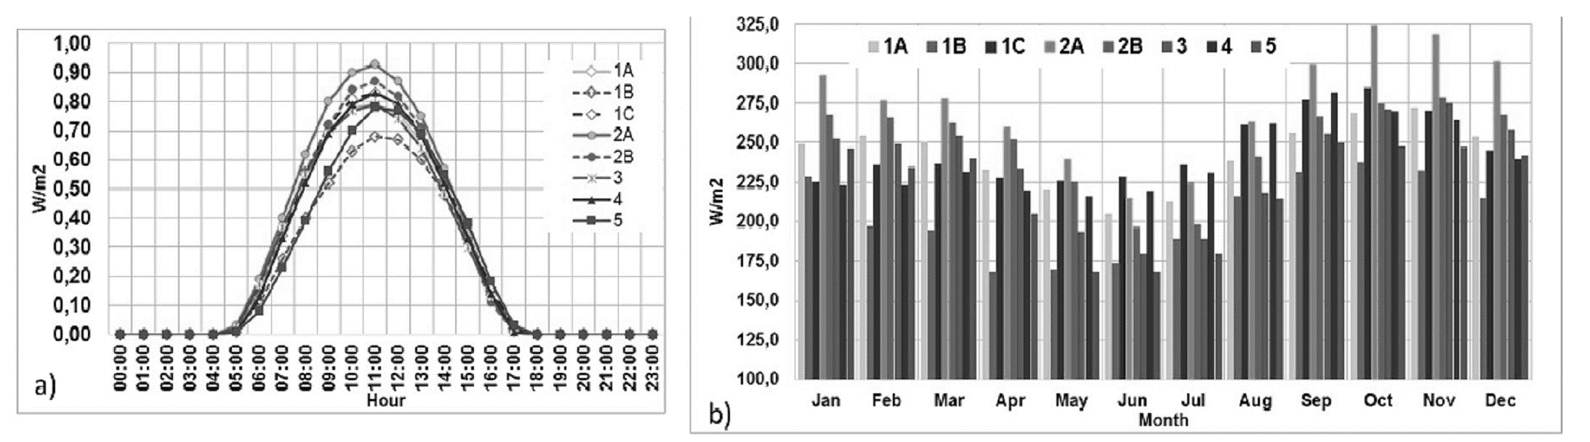
Fig. 1 – Solar radiation data. In a) the typical irradiation day; and b) the typical annual cycle.

3. Methodology and Results
For the study, it was used a 3 MW turbine with 125 meters’ rotor diameter at 100 meters’ axle height. The electrical power output was estimated using energy generated according to the power curve for each wind speed 10-minute interval. As the power curve used was at standard density, i.e., , wind velocity went through an adjustment according to the local air density for each site. The follow relation was used as recommended by the IEC 61400-12-1[20]:

(1)

With that, it was obtained the average hourly energy generation for each month. From the energy results, it was subtracted a standard loss amount of 13% of the energy (availability, wake, electrical transmission, shutdown time and environmental).
A 1MW solar PV farm was designed containing: Si-poly modules of 320Wp each (16.46% efficiency), an inverter of 1000kW and one axis tracking system (-60°/+60°). The arrangement resulted in 28 PV modules in series and 145 strings in parallel, in a 6 meters’ pitch, with a PV array global power of 1,299kWp with a DC/AC ratio of 1.3. Averaged year of GHI and temperature data, as well as the PV arrangement, were insert in the PVsyst [21–26], a solar PV simulation performance modelling software, developed by the University of Geneva. For the incident irradiance calculus was used Perez’s transposition model. For the simulation PVsyst ran in default regarding the losses (mismatch, soil, thermal, ohmic, shading, others).
As this work aims to use full wind farm substation transformer power rate (limited to ≤ 115%) with addition of solar energy, maximize the daily electricity production and, at the same time, minimize the downtime wind energy season. At last, avoiding curtailment time was desirable but not imperative letting, if necessary, a small percentage of potential curtail. After simulations, a fraction of solar for daily and mix daily/night wind pattern was found as,
( 2)

for the entirely nocturnal wind pattern where the sunrise (sunset) are the turning point to a below (above) averaged wind, the best relation to estimate solar amount is,
(3 )

where,
is the solar PV power amount as complementary to the wind farm;
is the total installed wind power;
wind power capacity factor;
PV power capacity factor.

For comparison, a typical windfarm with 30MW was considered for each site. The best fit of solar is calculated by the using Eq.2 (Area 1 A and B, Area 2 A and B, Area 4) and Eq.3 (Area 3 and 5 with nightly wind regime). The simulation results are shown in Table 3. The different capacity factor for wind farms, in this experiment, are due only to the wind distribution. In a real wind farm, orography, soil use, wake effects and transmission line distance would play a significant weight on results. Fig. 2 illustrates the energy production of two different wind regimes. The parts a) and b) show the near coast wind farm with production during the day as well as solar. The amount of solar added is less than one third of wind. As the production cycle coincides there is some power curtail in place, mostly for the windy months between 11a.m and 1 p.m. During the weak wind months, solar PV complement the production adding from 26 to 46% in energy.
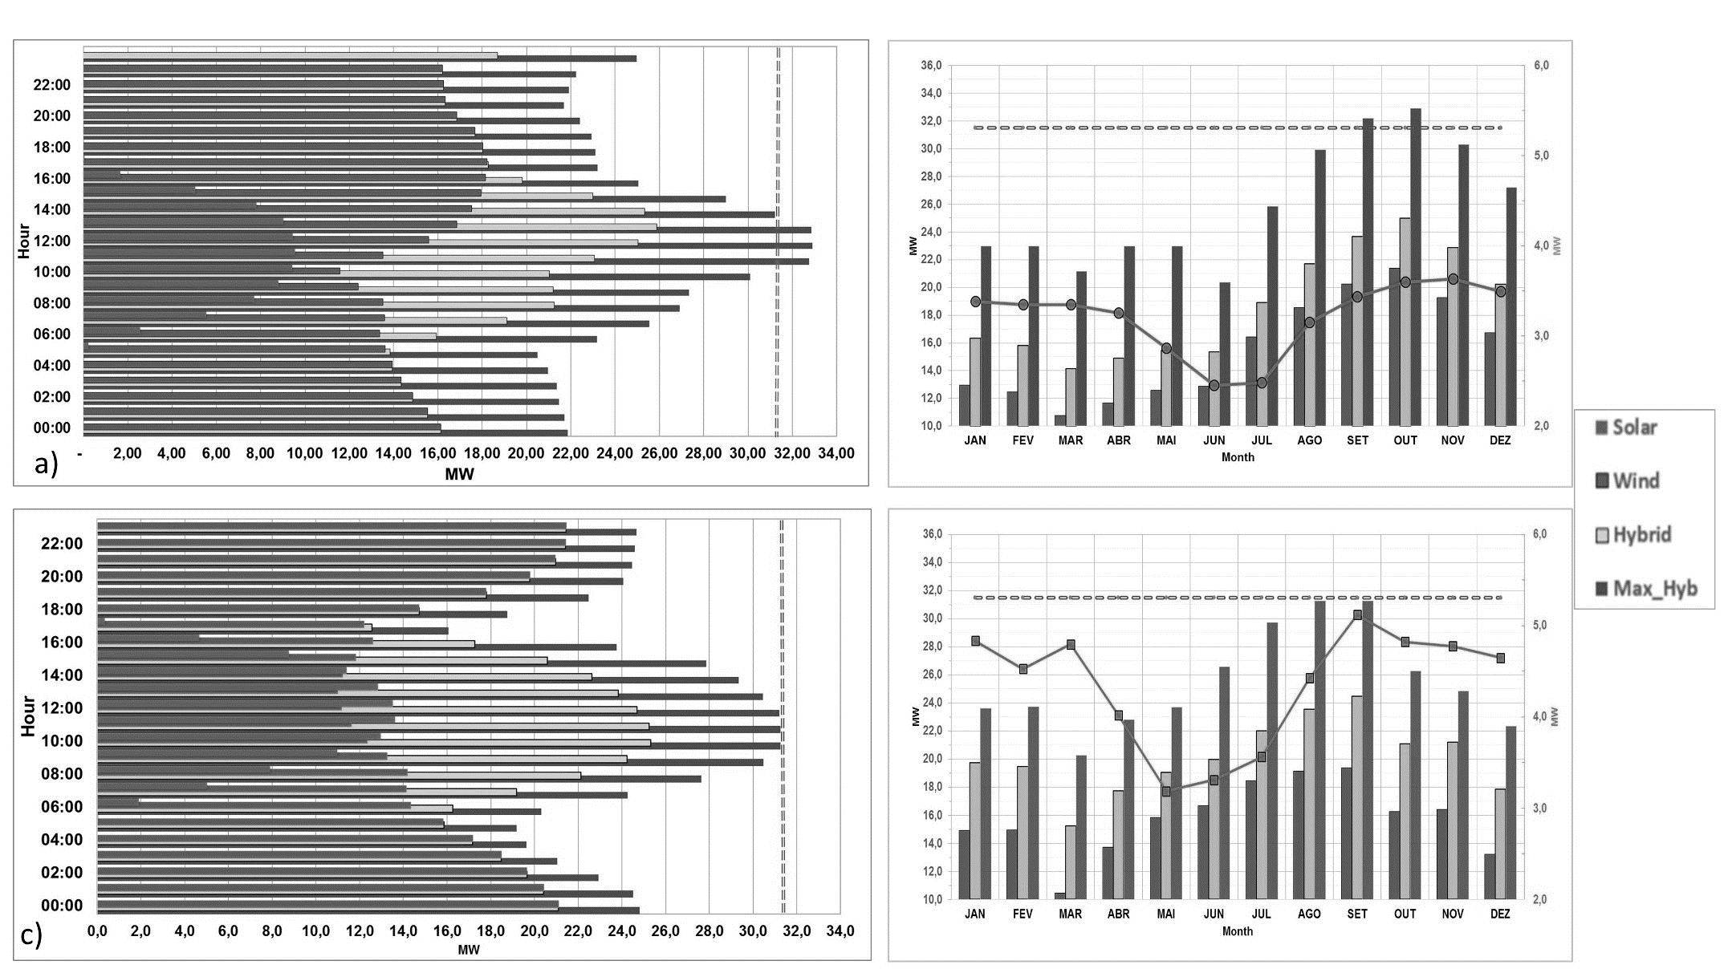
Fig. 2 – Two wind patterns: a) and c) typical diurnal (nightly) wind power production with associated solar (PV), the hybrid system (wind + PV) and the maximum hourly production. The dashed vertical line indicates the transformer limit. In b) and d) the annual cycle for a daily (night) wind regime with wind, solar (line), hybrid (wind + PV), and the maximum hourly power generated in each month.

Table 3 – Wind and solar PV complementarity for all wind regimes.
Area | Site | (%) | (%) | to 30 MW (MW) | Curtailment hours-(>115% Transformer load |  | Energy Added  (%) | Energy added in low wind month (%)
 |  |  |  |  | Month | Time of day(hour) | Energy Added  (%)
1 | A | 0.59 | 0.32 | 8 | Aug | 08-09 | 17% | Mar | 38
 |  |  |  |  | Sep | 08-10 | 17% | Apr | 27
 |  |  |  |  | Nov | 14 | 17% | May | 21
1 | B | 0.61 | 0.25 | 9 | Aug | 11-14 | 12% | Mar | 16
 |  |  |  |  | Sep | 10-14 | 12% | Apr | 19
 |  |  |  |  | Oct | 09-14 | 12% | May | 13
1 | C | 0.49 | 0.32 | 10 | Aug | 08-09 | 23% | Mar | 22
 |  |  |  |  | Sep | 07-09 | 23% | Apr | 27
 |  |  |  |  | Oct | 07-09 | 23% | May | 26
2 | A | 0.52 | 0.33 | 10 | Sep | 12-13 | 22% | Mar | 31
 |  |  |  |  |  |  |  | Apr | 28
 |  |  |  |  | Oct | 11-13 | 22% | May | 23
2 | B | 0.57 | 0.32 | 9 |  |  | 24% | Mar | 19
 |  |  |  |  |  |  |  | Apr | 21
 |  |  |  |  |  |  |  | May | 17
3 | 3 | 0.52 | 0.31 | 16 | Aug | 09 | 30% | Mar | 40
 |  |  |  |  | Sep | 08-10 | 30% | Apr | 30
 |  |  |  |  | Oct | 07-08 | 30% | May | 30
4 | 4 | 0.56 | 0.32 | 9 | Jul | 07-10 | 17% | Mar | 22
 |  |  |  |  | Aug | 07-11 | 17% | Apr | 18
 |  |  |  |  | Sep | 08-09 | 17% | May | 14
5 | 5 | 0.53 | 0.27 | 16 |  |  | 27% | Mar | 46
 |  |  |  |  |  |  |  | Apr | 29
 |  |  |  |  |  |  | 27% | May | 20

ConclusionS
In this study wind and solar radiation regimes for Northeastern Brazil region were assessed. Even though the whole region is under the trade winds influence, different wind regimes were found indicating that a combination of wind farm could result in a smoother power generation daily cycle.
Solar radiation has a significant potential in the region as showed by the resultants of the PV simulations. Power production from both renewable sources were simulated and two equations to the best amount of solar fit in any wind farm power production pattern were found.
A wind and solar PV system in the same electrical infrastructure as a hybrid was quite studied in a standalone generation system [27].
Even though the national power grid operator does not allow a hybrid wind/solar system to be connected at the present there is a bottleneck in the transmission system. Exploring the full rated power at a windfarm with solar would add in average 20% more energy to the grid per year.
In sites with daily wind pattern, solar PV would complement weak wind morning hours. At peak hours of solar and wind, usually late morning to early afternoon, instead of curtail, the solar energy surplus could be used to allow turbine maintenance or low turbine availability.
Solar PV would add more than 30% energy to the critical months of weaker winds, as March and April in Northeast region.
Examining the annual cycle for the two renewable sources is fair to conclude that they are a natural complement to the hydropower generation once they the peak of generation during the dry and sunny months.
This study succeeded on demonstrating the complementarity of wind and solar energy in Northeast Brazil and indicates that hybrid wind and solar plants may maximize the usage of the two renewable resources.
For future research it is suggested to evaluate the potential complementarity among all regions in Brazil in a 10 minute interval.

References
[1] J.H. Ausebel, The Liberation of the Environment, Daedalus. 125 (1996) 1–17.
[2] D. Ren, Effects of global warming on wind energy availability, Renewable and Sustainable Energy Reviews. 2 (2010) 1–5. doi:10.1063/1.3486072.
[3] A.F. Pereira de Lucena, A.S. Szklo, R. Schaeffer, R.M. Dutra, The vulnerability of wind power to climate change in Brazil, Renewable Energy. 35 (2010) 904–912. doi:10.1016/j.renene.2009.10.022.
[4] A. Torres Silva Dos Santos, C.M. Santos E Silva, Seasonality, interannual variability, and linear tendency of wind speeds in the Northeast Brazil from 1986 to 2011, The Scientific World Journal. 2013 (2013). doi:10.1155/2013/490857.
[5] EPE/MME, RELATÓRIO DE GESTÃO DO EXERCÍCIO DE 2014, Rio de Janeiro, 2010. http://www.epe.gov.br/PrestacaoDeContas/Lists/PrestacaoDeContas/Attachments/38/Relatorio de Gestao 2014 - EPE.pdf.
[6] C. Wang, Chapter 6 ENSO , ATLANTIC CLIMATE VARIABILITY , AND THE WALKER AND HADLEY CIRCULATIONS, (n.d.) 173–202.
[7] R.P. Kane, Prediction of droughts in north-east Brazil: Role of ENSO and use of periodicities, International Journal of Climatology. 17 (1997) 655–665.
[8] M.T. Kayano, R. V Andreoli, Relationships between rainfall anomalies over northeastern Brazil and the El Niño – Southern Oscillation, 111 (2006) 1–11. doi:10.1029/2005JD006142.
[9] EPE, Webmap EPE, (2016) 1. https://gisepe.epe.gov.br/WebMapEPE/.
[10] CEPEL, Brazilian Atlas of wind potential, Rio de Janeiro, 2001. http://www.cresesb.cepel.br/publicacoes/download/atlas_eolico/Atlas do Potencial Eolico Brasileiro.pdf.
[11] F.R. Martins, S.L. Abreu, C.S. Chan, R. Rüther, O. a. C. Amarante, Solar and Wind Energy Resource Assessment in Brazil. SWERA Report, 2008.
[12] J. Appelbaum, Shadow analysis of wind turbines for dual use of land for combined wind and solar photovoltaic power generation, Renewable and Sustainable Energy Reviews. 55 (2016) 713–718. doi:10.1016/j.rser.2015.11.09.
[13] C.B. Uvo, C.A. Repelli, S.E. Zebiak, Y. Kushnir, The relationships between tropical Pacific and Atlantic SST and northeast Brazil monthly precipitation, Journal of Climate. 11 (1998) 551–562. doi:10.1175/1520-0442(1998)011<0551:trbtpa>2.0.co;2.
[14] A.K. Azad, M.G. Rasul, M.M. Alam, S.M. Ameer Uddin, S.K. Mondal, Analysis of wind energy conversion system using Weibull distribution, Procedia Engineering. 90 (2014) 725–732. doi:10.1016/j.proeng.2014.11.803.
[15] N.C. Ali, A statistical analysis of wind power density based on the Weibull and Rayleigh models at the southern region of Turkey, Renewable Energy. 29 (2003) 593–604. doi:10.1016/j.renene.2003.07.002.
[16] M.H. Al-buhairi, A. Al-haydari, Monthly and Seasonal Investigation of Wind Characteristics and Assessment of Wind Energy Potential, Energy and Power Engineering. 4 (2012) 125–131. doi:http://dx.doi.org/10.4236/epe.2012.43017.
[17] L. de Araujo Lima, C.R. Bezerra Filho, Wind energy assessment and wind farm simulation in Triunfo - Pernambuco, Brazil, Renewable Energy. 35 (2010) 2705–2713. doi:10.1016/j.renene.2010.04.019.
[18] V.B. Rao, K. Hada, Characteristics of Rainfall over Brazil: Annual Variations and Connections with the Southern Oscillation, Theoretical Applied Climatology. 42 (1990) 81–90.
[19] S. Hastenrath, Exploring the climate problems of Brazil ’ s Nordeste : a review, Climate Change. 112 (2012) 243–251. doi:10.1007/s10584-011-0227-1.
[20] IEC 61400-12-1: Power Performance Measurements of Electricity Producing Wind Turbines., 2005.
[21] K.J. Sauer, T. Roessler, C.W. Hansen, Modeling the irradiance and temperature dependence of photovoltaic modules in PVsyst, IEEE Journal of Photovoltaics. 5 (2015) 152–158. doi:10.1109/JPHOTOV.2014.2364133.
[22] C.P. Kandasamy, P. Prabu, K. Niruba, Solar potential assessment using PVSYST software, Proceedings of the 2013 International Conference on Green Computing, Communication and Conservation of Energy, ICGCE 2013. (2013) 667–672. doi:10.1109/ICGCE.2013.6823519.
[23] L. Yalcin, R. Ozturk, Perfoemance comparison of C-Si, mc-Si and a-Si thin film PV by PVsyst simulation, Journal of Optoeletronics and Advnaced Materials. 15 (2013) 326–334.
[24] A. Rix, T. Mahachi, PVsyst MODEL IMPROVEMENT USING FIELD DATA FROM A 75 p SOLAR PV POWER PLANT, in: 24th Southern African Universities Power Engineering Conference, Vereeniging, 2016. doi:10.13140/RG.2.1.2518.6168.
[25] O.W. Westbrook, F.D. Collins, Energy model validation for large-scale photovoltaic systems, Photovoltaic Specialists Conference (PVSC), 2013 IEEE 39th. (2013) 830–835. doi:10.1109/PVSC.2013.6744274.
[26] A. Mermoud, OPTIMIZATION OF ROW-ARRANGEMENT IN PV SYSTEMS, SHADING LOSS EVALUATIONS ACCORDING TO MODULE POSITIONING AND CONNEXIONS, in: 27th European Photovoltaic Soalr Energy Conference, Frankfurt, 2012.
[27] P. Nema, R.K. Nema, S. Rangnekar, A current and future state of art development of hybrid energy system using wind and PV-solar: A review, Renewable and Sustainable Energy Reviews. 13 (2009) 2096–2103. doi:10.1016/j.rser.2008.10.006.

AUTHOR’S RESUMÉ
Caarem Studzinski – Brazilian native. PhD student at UFRGS (2014-2017 – thesis). MSc in Meteorology by INPE/Brasil (1995), M.D. in Environment Management by PROENCO/LNCC (2004), specialized in Energy Forecast model by LBL/Berkeley (2000) and in climate models by Columbia University/NY (LDGEO) (1994). Meteorologist (1983- UFPEL/RS) and Aeroespacial Senior Specialist in wind and solar energy assessment and technical diligence. Scientific papers on climate, MTBF techniques and weather forecast. Complete bio in http://buscatextual.cnpq.br/buscatextual/visualizacv.do?id=K4780124Z1
Rita de Cassia Alves Marques – Brazilian native. Dr. in Meteorology by USP/Brasil (2000). Meteorologist by UFPEL (1993). Full time professor and researcher of Geosciences Dept. at UFRGS. Main research focus is micrometeorology and natural disasters. Main areas of interest are air pollution dispersion models, atmospheric modelling, microscale modelling and remote sensing. Complete bio in http://buscatextual.cnpq.br/buscatextual/visualizacv.do?id=K4797294E6.
Pedro A. Rosas – Brazilian Native, PhD in Electric Eng. by Technical University of Denmark (2003), full time professor at UFPE, long time researcher in Windpower grid integration. Engineer by Universidade Federal de Pernambuco (1996), Master in Mechanical Eng. By UFPE (1999). Main research areas are: grid integration, off-grid, electromagnetic compatibility, wind turbine modelling and quality of energy. Complete bio in http://lattes.cnpq.br/5539599537097451.

Corrected to the wind farm altitude

