Windfarm Grounding Simulation and Performance Calculation
Paulo Edmundo da Fonseca Freire ¹, Patricia de Lugão and Berthold Kriegshäuser ²
1 PAIOL Engenharia, Consultoria e Projetos Ltda.
2 Strataimage Consultoria LTDA.
Av. Dr. Heitor Nascimento 196, Bloco A, sala 29, Paulínia/SP, Brazil, CEP 13140-729
paulofreire@paiolengenharia.com.br, patricia.lugao@strataimage.com, berthold@strataimage.com
ABSTRACT
The design of the grounding system of a windfarm, due to its wide dimensions, requires more complex geoelectric models and simulating software, than the usual models and software used for the design of a typical substation. In this paper we present average apparent resistivity curves of different windfarms situated at the Northeast of Brazil, located in the states of Bahia and Rio Grande do Norte. These curves show that, in general, ground resistivity is high at these sites, resulting in high grounding resistances for the windfarm towers. In this study we discuss the use of geoelectric models built from the combination of two types of geophysical soundings - the traditional Wenner method, which can prospect only the shallow ground, combined with the AMT – Audio Magnetotelluric Method, which can prospect down to 2 km deep. The paper also highlights the need of simulating the windfarm grounding system with a software that considers the voltage drops in the grounding conductors, because the premise of equipotentiality of the grounding system does not apply. The application of the suggested modeling is applied for a typical windfarm, with the construction of a deep geoelectric model and evaluation of the electrical performance of this system when subjected to the injection of currents with two different frequencies - 60 Hz, to simulate a short-circuit in the medium-voltage network, and 25 kHz, to simulate a lightning strike.

WINDFARM GROUNDING
Windfarms, considering the aerogenerators and the medium-voltage transmission lines, can be classified as facilities with extreme exposure to the effects of lightning, usually due to a combination of several critical conditions, such as:
- unsheltered areas, very exposed to the direct incidence of lightning;
- tall towers and long blades, which favor the formation of positive ground-to-cloud lightning;
- high resistivity ground, which makes it difficult to obtain a low resistance grounding;
- very frequently the interconnections are done by overhead medium voltage lines, also very exposed to the effects of direct and indirect lightning.
The grounding of an aerogenerator tower can be analyzed considering two parameters:
- impulsive impedance - response to a current impulse, which may be the grounding impedance viewed by the front wave of a lightning at t = 0+, immediately after its incidence; and
- leakage resistance - valid for low frequencies, as is the case of a short-circuit to ground in the medium voltage network, which is the resistance viewed by the impulse tail, after the transient associated with the lightning front-wave [1].

GEOELECTRIC MODELS FOR WINDFARM GROUNDING DESIGN
The orthotropic model – the same resistivity in the horizontal plane but varying with depth (1D geoelectric model), is the traditional option for simulating grounding electrodes within the electrical engineering community. For the electrical engineer, ground is the medium through which electrical currents can flow, usually associated with power grids operation, or where a grounding electrode will be buried. The ground is understood as the entire volume of this medium electrically influenced by the grounding system. A simple classification under the engineering point of view, divides Earth’s “near-surface” (first few hundred meters below the soil surface) in 3 layers:
- topsoil – cultivation soil layer, dry unconsolidated material with medium resistivity (sand, clay etc.), frequently designated as the Ap layer or horizon;
- subsoil – older sediments with fragmented and/or partially decomposed rock (alteration rock or regolith), from low to high resistivity, depending mainly on the water content;
- bedrock or basement - solid or fissured rock matrix (but not fragmented), with high resistivity, composed of basalts, granites, gneisses etc., below the unconsolidated materials.
The geoelectric structure of the near-surface ground for a specific windfarm can only be obtained based on field surveys. The following items present the two geophysical methods proposed in this paper for the geoelectric modeling of the ground for the design of windfarm grounding systems – the Wenner and the AMT methods. Figure 1 presents the measuring setup for both methods. The geoelectric models obtained from the combination of these two geophysical methods can reach down to 1-2 km deep, being these depths compatible with the dimensions of a typical windfarm and with the depth of return of the AC currents injected into the ground by short-circuits.

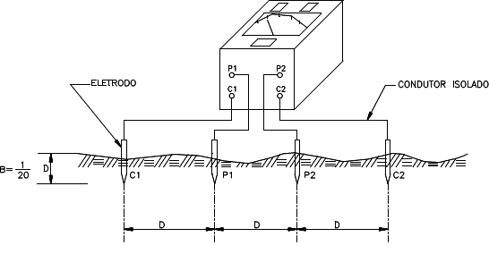 | 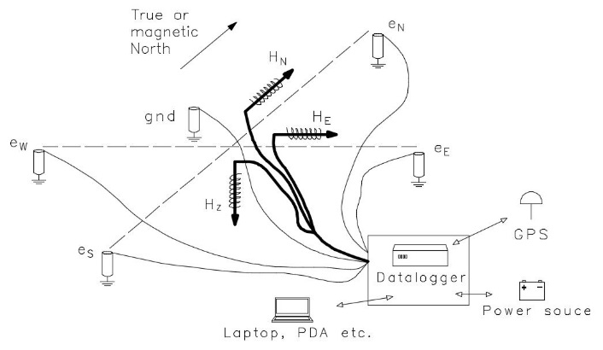
Figure 1: measuring setup for the Wenner and AMT/MT soundings.

Vertical Electrical Soundings (VES)
Windfarm grounding design has been traditionally developed based on very shallow geoelectric models, obtained usually from Wenner soundings with limited spacing (up to a maximum of 32 m). This practice is not compatible with the dimensions of the windfarms, and it is not possible to say if these designs present conservative or pessimistic results, since the resistivity of the deeper ground layers are usually unknown.
The shallow ground ranges to a depth of tens of meters and can be sounded by means of the injection of currents at soil surface, allowing for the surveying of geoelectrical structures less than 100 m deep. The electroresistivity method infers the shallow subsurface geoelectric structure by employing an artificial source of DC or low frequency current and four electrodes, two for current injection (A and B) and two for potential measuring (C and D). The ratio between the measured voltage ∆V and the corresponding injected current (I) allows for the calculation of the apparent resistance (Rapp = ∆V/I), which is converted to apparent resistivity by means of specific formulas that consider the electrodes configuration.
The Wenner and Schlumberger arrangements are the traditional VES configurations. Empirical rules of thumb for depth of investigation state AB/4 for a Schlumberger array and a (the interelectrode spacing) for a Wenner array [2]. These are optimistic depths, because the probing depth depends on other parameters than only the spacing, such as the resistivity of the shallow ground layers, and characteristics of the measuring equipment (DC or AC, power, sensibility, noise filtering resources etc.). As a matter of a fact, the typical probing depth is much shallower than expected, generally reaching only a few meters or up to 10 m.
Another important consideration is the static-shift, a vertical deviation of the apparent resistivity curve, due to resistivity inhomogeneities of the surficial ground layer, where the potential probes are driven. These surficial inhomogeneities introduce small potential sources at the interfaces with the dominant ground layer, which are summed to the measured potentials. To compensate for these deviations, the measurement of a statistical sampling of the shallow ground (more than 20 VES) is recommended, which shall be averaged with a geometric mean. This procedure is not any problem for the shallow survey at a windfarm, because its large dimensions will usually demand for a significant number of VES soundings.

The Audio-Magnetotelluric Method
Near-surface ground can be defined to a depth of a few hundreds of meters and its resistivity distribution can be derived with the help of applied electromagnetic fields, allowing for probing geoelectrical structures down to 2 km depth. TDEM (time-domain electromagnetic) and AMT (audio-magnetotelluric) are two electromagnetic methods, which survey the near-surface.
AMT sounding requires the simultaneous measurement of time series of the orthogonal components of magnetic (Bx, By and Bz) and electric (Ex and Ey) fields, originated mainly from electromagnetic waves irradiated worldwide by lightning storms, which propagate within the spherical Earth–ionosphere waveguide with low attenuation [3]. AMT sounding is very practical, because an hour is typically long enough for recording good AMT data time series in the frequency range of 10000–0.1 Hz, allowing for sampling the upper 1-2 km of the ground and for collecting information on the geoelectric structure of the bedrock. More information on AMT and MT with case histories in Brazil can be found e.g. in de Lugão et al. [4].

SIMULATION OF A WINDFARM GROUNDING SYSTEM
Figure 2 presents the average apparent resistivity curves of several windfarms located in the Northeast of Brazil (states of Bahia and Rio Grande do Norte), where we can be observed a wide range of resistivities, with the prevalence of high-resistivity ground. The decreasing trend of the apparent resistivity with the measuring electrodes spacing, found in most of the curves, reveal that in these models the rocky basement was not sensed by the Wenner sounding, resulting thus, in optimistic geoelectric models.
The simulation of the grounding system of a windfarm requires more complex models than the ones usually adopted for the design of grounding grids of small and medium-sized power substations. Among the fundamental premises required for a realistic modeling and simulation of a windfarm grounding system, with dimension of the order of kilometers, the following two shall be highlighted:
- the voltage drops that occur in the grounding conductors shall be considered – because the premise of equipotentiality of the grounding system does not applies;
- deep geoelectric models are required, at least about 1 km deep.
For the simulations presented in the next items, the Wenner and AMT data were inverted with the help of the one-dimensional inversion software IPI2WIN, which performs an automated approximation of an initial resistivity model using the observed data. The simulations of the grounding system were carried out using the commercial software CDEGS.
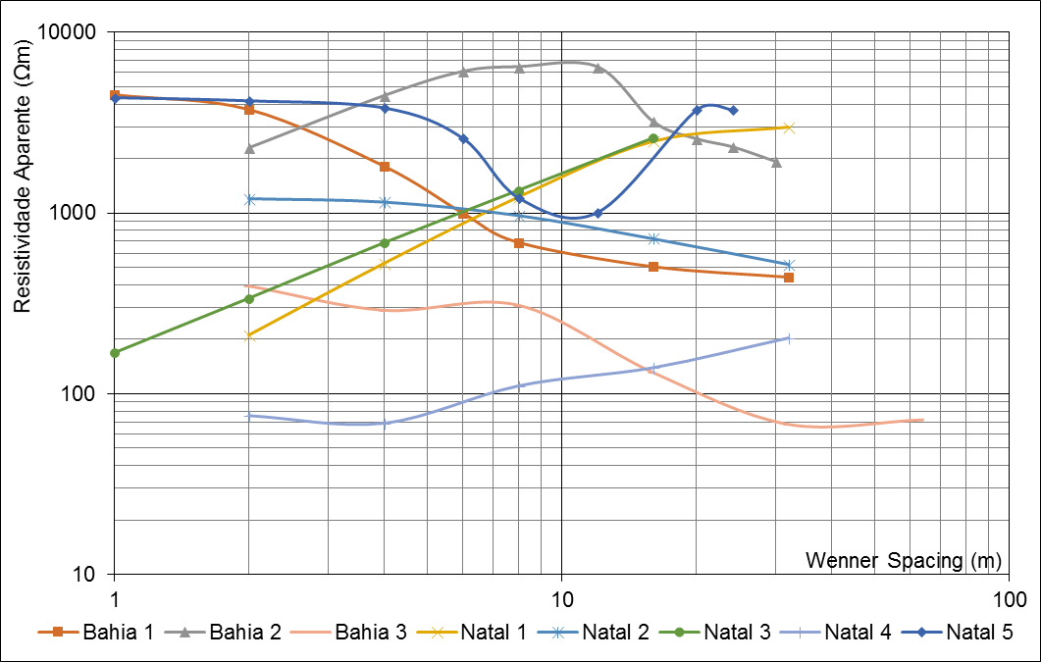
Figure 2: average apparent resistivity curves for several windfarms located in Northeast of Brazil.

Geoelectric Model for Windfarm Bahia 1
Two different geophysical surveys were performed, one consisting of eight Wenner VES soundings and one near-surface AMT survey consisting of four soundings. The 8 Wenner soundings were reduced to a geometric average curve. The four AMT soundings, along a 1,5 km transect, were consistent, resulting in four sets of apparent resistivity and phase curves. Figure 3 presents the 2D ground section down to 6 km depth below soil surface, along the AMT profile, where it is clear the existence of a medium-resistivity ground layer, about 500 m thick, above a lower resistivity ground layer.
Each AMT sounding was averaged individually, resulting in the invariant (1D) apparent resistivity and phase curves, and then the four curves were averaged again, to achieve a geoelectric model representative of the entire transect. Figure 4 presents the average Wenner (blue) and AMT (orange) apparent resistivity curves. The complementarity of the two soundings is very evident, as the AMT curve starts just after the Wenner curve finishes. To plot the two curves on the same graph, the Wenner spacings (measured in meters) were converted to periods (measured in seconds), applying the expressions established by Meju [5].
The Wenner average apparent resistivity curve was inverted resulting in the shallow geoelectric model, as presented in Figure 5. This model was applied as a constraint for the inversion of the AMT average curves, as presented in Figure 6, which shows the average AMT apparent resistivity and phase curves (black), the inverted ones (red), and the calculated 8-layer geoelectric model (blue line and table), with a total deviation less than 10%. The model is consistent with the geoelectric ground section of Figure 2, showing that below the medium-resistivity ground layer, with about 500 m width, there are low resistivity ground layers.
The complex geoelectric structure of the windfarm was not prospected by the Wenner survey, which can detect only the first six meters of high-resistivity ground and then the trend of decreasing resistivity. A geoelectric model deep enough to be compatible with the dimensions of a windfarm was achieved, probing the shallow and near-surface ground structure, demonstrating the importance of combined ground survey with two complementary geophysical methods - the Wenner and AMT.
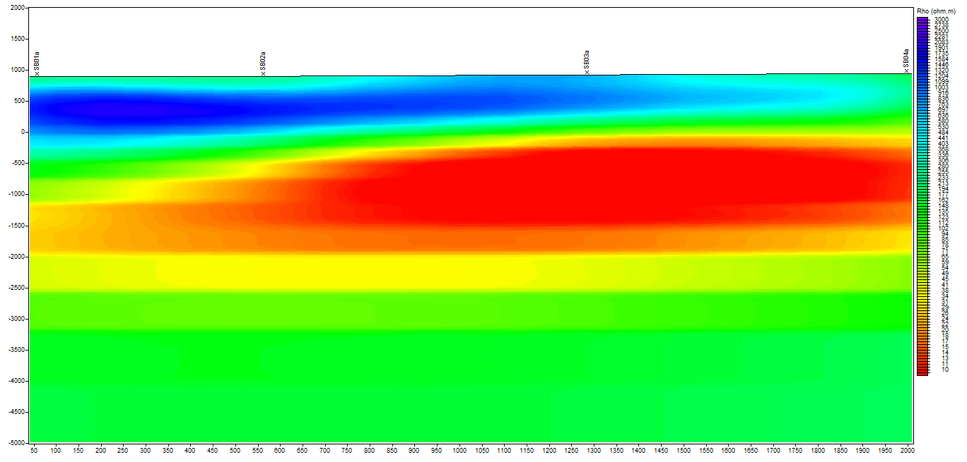
Figure 3: near-surface ground section (down to 6 km depth below soil surface) along the transect of the four AMT soundings (1,5 km long).
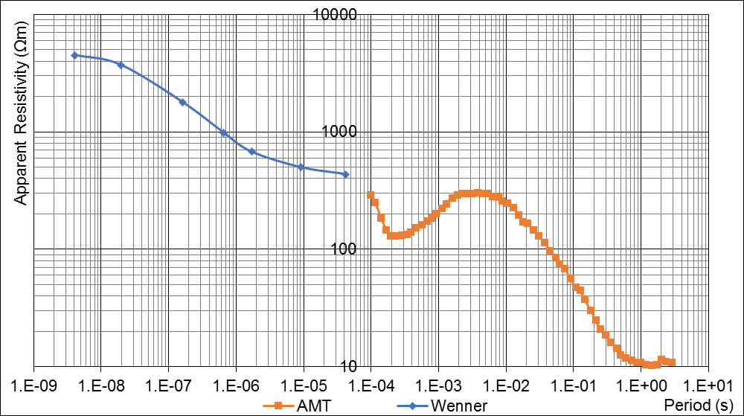
Figure 4: 1D average apparent resistivity curves - Wenner (blue) and AMT (orange).
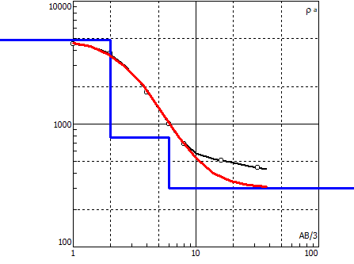 | 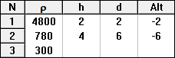
Figure 5: Wenner apparent resistivity curves - average (black) and inverted (red), and corresponding three-layers geoelectric model (blue line and table).
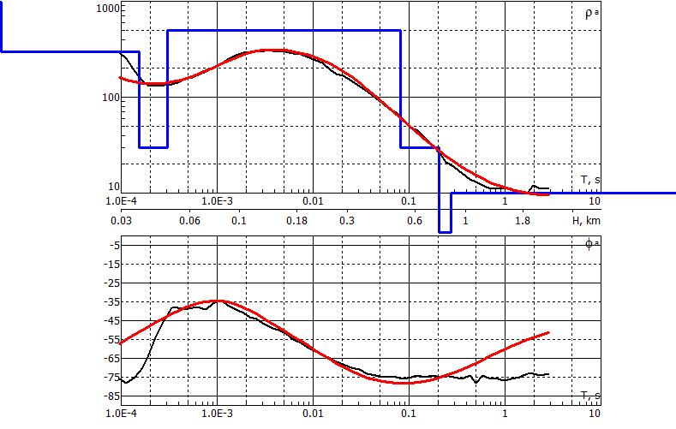 | 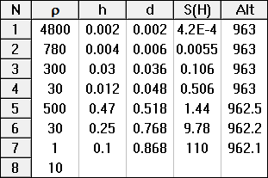
Figure 6: AMT apparent resistivity and phase curves - invariant (black) and inverted (red), and corresponding eight-layers geoelectric model (blue line and table), with error below 10%.

Modeling the Grounding System of Windfarm Bahia 1
For the following simulations we considered windfarm Bahia 1, with 12 towers, each 230 m apart in average (Figure 7), and with the following characteristics:
- at the base of each tower the low-voltage generation is elevated to medium-voltage (typically 34.5 kV), and interconnected to the medium-voltage distribution line;
- the typical grounding of each tower consists of 70 mm² bare-copper cable rings connected to the steel reinforcements of the tower foundation, with additional radial grounding conductors intended to improve grounding performance for impulsive discharges (lightning strikes);
- the tower groundings are interconnected by the 8 mm copper-steel ground-wire of the medium-voltage line, with 3 rods between each tower, each one with a single 3 m copper-steel rod;
- the medium-voltage line interconnects the wind generators to a collecting substation, which raises the medium voltage to a sub-transmission (69 kV) or transmission level (138 kV or 230 kV) and provides the connection with the interconnected transmission net.
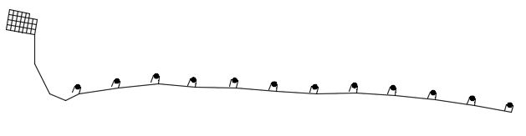 | 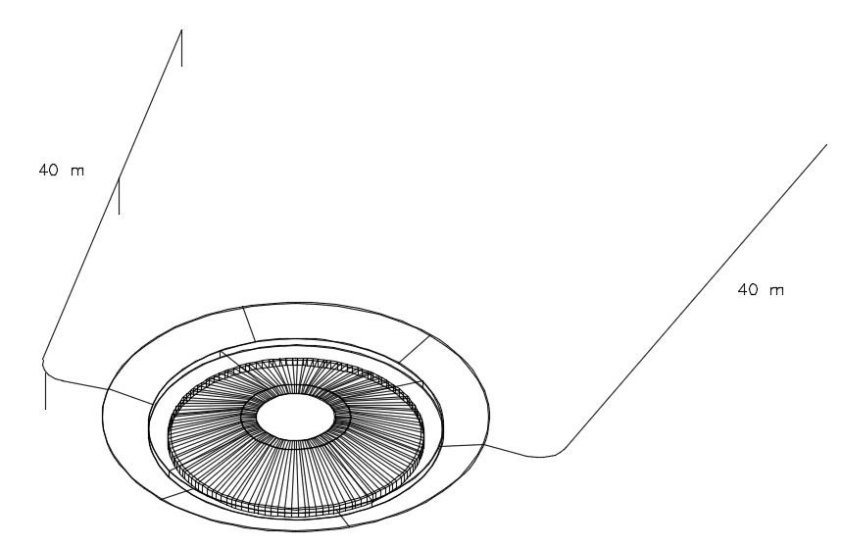
Figure 7: the windfarm grounding system - tower bases and substation grounding grid interconnected by the ground-wire of the medium voltage line, and detail of a tower grounding.

Results of the Simulations
Simulations were carried out for three grounding configurations:
- single tower, with the steel reinforcement interconnected to 70 mm² bare copper cable rings;
- 12 towers with a 40 m x 70 mm² bare copper cable and 3 rods, interconnected by the ground-wire of the medium-voltage line;
- previous configuration, with two bare copper cables of 40 m x 70 mm² and 3 rods for each tower.
The current injection was done in the 6th tower after the substation, with two frequencies, for the calculation of the grounding impedance for two situations:
- 60 Hz - a short-circuit at the terminals of the elevating transformer at the base of the tower;
- 25 kHz – to simulate the response to a lightning strike on the blade of the aerogenerator.
Table 1 presents the grounding parameters calculated for the two geoelectric models (shallow and deep), for the three configurations above and for the two current injections (60 Hz and 25 kHz). For the 60 Hz current injection it is reasonable to refer to the grounding resistance, however, for the 25 kHz it is more appropriate to refer to the grounding impedance.
Table 4.1: grounding impedances for a current injection in the 6th tower foot.
Grounding Configuration | 60 Hz  resistance | 25 kHz  impedance
Single tower grounding | 18,25 Ω | 18,32 Ω
Single tower with one radial cable | 15,29 Ω | 15,43 Ω
Single tower with two radial cables | 14 Ω | 14,2 Ω
12 towers connected (each with one radial cable) | 1,2 Ω | 14,5 Ω
12 towers connected (each one with two radial cables) | 1,1 Ω | 13,4 Ω

CONCLUSIONS
The standard IEC-TR61400-24 [6] presents several tables with statistics of lightning events in wind turbines, with the occurrence of several damages. Brazil, being a tropical country with a higher incidence of lightning than Europe, is more exposed to the damages caused by lightning strikes, both due to a direct strike at the blade of the wind-generator or due to the short-circuit in the medium-voltage line, initiated by a strike, which may be direct or indirect (induced).
The analysis presented in this work reveals that a reliable geoelectric model of the ground is important for the modeling of large grounding systems, such as the ones of the windfarms. For grounding systems of this size, the consideration of equipotentiality does not apply, since significant potential differences will occur within its components, both for the direct lightning strike in one wind-turbine or for the occurrence of line-to-ground faults in the medium-voltage network.
The construction of geoelectric models compatible with the large dimensions of a windfarm including the basement rock depends on the combination of apparent resistivity curves measured with different geophysical methods, to reach depths of a few hundred meters.
The electrical methods (Wenner and Schlumberger) can sense only the shallow ground layers, down to a few tens of meters, but in the usual case limited to below 10 m due to limitations of equipment and spacing between probes. The near-surface methods (AMT and TDEM) can reach depths typically up to 1-2 km. The latter, despite allowing for deep models, do not sense the shallow ground (where the grounding system is buried), and for this reason the combination of different geophysics sounding methods is the best solution for achieving a reliable geoelectric model.
The availability of deep geoelectric models, compatible with the size of the windfarms, combined with powerful computational resources, capable of simulating complex and non-equipotential grounding systems, buried in multilayer geoelectric models, allows for the elaboration of more reliable and economical designs of grounding systems, which will result in higher operational reliability and safety levels in general.
The simulations of this study, compatible with a typical windfarm, showed that the grounding resistance and impedance of a single tower is quite similar for the two frequencies considered (60 Hz and 25 kHz), being both values above the usual 10 Ω required by the aerogenerators suppliers. The use of radial cables for reducing the grounding resistance, as suggested by IEC-TR61400-24, reduces in almost 20% the resistance and impedance of the tower base, not enough for achieving the desired 10 Ω, at least for the case simulated. However, for the complete windfarm, with the towers connected by the ground-wire of the medium-voltage line, this limit is easily achieved for the 60 Hz resistance. For the 25 kHz current injection, even with the interconnection of the tower groundings, the desired 10 Ω impedance is not achieved.
The conclusion is that for a typical windfarm, built in medium to high-resistivity grounds, the desired 10 Ω grounding resistance can be achieved only with the interconnection of the tower groundings. The ground-wire of the medium-voltage transmission line will allow for this impedance reduction, however, the use of bare-cable buried in the ground for these interconnections will be certainly more effective.

ReferencES
[1] Freire PEFF. Pereira SY. Windfarm Grounding. 2016 CIGRE C4 International Colloquium on EMC, Lightning and Power Quality Considerations for Renewable Energy Systems. Curitiba. Brazil. 2016.
[2] Barker RD. Depth of investigation of collinear symmetrical four-electrode arrays. Geophysics, Vol. 54. Number 8. pp. 1031-1037. August 1989.
[3] Garcia X. Jones AG. Atmospheric sources for audio-magnetotelluric (AMT) sounding. Geophysics. Vol. 67, No. 2. pp. 448–458. March-April 2002.
[4] De Lugão P. Kriegshäuser B. Menezes A. Pastana A. Nunes D. Correa E. Gomes K. and Matla L. Recent applications of the magnetotelluric method for onshore oil&gas exploration in Brazil. 67th Ann. Internat. Mtg. Soc. Expl. Geophys. Expanded Abstracts. p. 1199-1203. 2017.
[5] Meju MA. Simple relative space-time scaling of electrical and electromagnetic depth sounding arrays: implications for electrical static-shift removal and joint DC-TEM data inversion with the most-squares criterion. Geophysical Prospecting 53. 2005.
[6] IEC-TR61400-24 - Wind Turbine Generator Systems - Part 24: Lightning Protection.

